

**Unit:**

**Dynamic Websites**

**Assignment title:**

**Air Pollution**

**Spring 2020 – Winter 2020**

|  |
| --- |
| **Important notes**   * Please refer to the *Assignment Presentation Requirements* for advice on how to set out your assignment. These can be found on the NCC Education website. Click on ‘Policies & Advice’ on the main menu and then click on ‘Student Support’. * You must read the NCC Education documents *what is Academic Misconduct? Guidance for Candidates* and *Avoiding Plagiarism and Collusion: Guidance for Candidates* and ensure that you acknowledge all the sources that you use in your work. These documents are available on the NCC Education website. Click on ‘Policies & Advice’ on the main menu and then click on ‘Student Support’. * You **must** complete the *Statement and Confirmation of Own Work*. The form is available on the NCC Education website. Click on ‘Policies & Advice’ on the main menu and then click on ‘Student Support’. * Please make a note of the recommended word count. You could lose marks if you write 10% more or less than this. * You must submit a paper copy and digital copy (on disk or similarly acceptable medium). Media containing viruses, or media that cannot be run directly, will result in a fail grade being awarded for this assessment. * All electronic media will be checked for plagiarism. |

Student Student ID: 00169589 Centers: DIA

Name: Bikash Chowdhury

**Marker's comments:**

**Moderator's comments:**

|  |  |  |
| --- | --- | --- |
| **Mark:** | **Moderated** | **Final** |
|  | **Mark:** | **Mark:** |



**Student Declaration**

I have read and understood NCC Education’s Policy on Academic Dishonesty and plagiarism.

**I can confirm the following details:**

**Program/Qualification Name :** L5DC

**Student ID/Registration number :** 00169589

**Name :** Bikash Chowdhury

**Center Name :** DIA

**Module Name :** Air Pollution

**Module Leader : Kazi Sanghati Sowharda Haque**

I confirm that this is my own work and that I have not plagiarized any part of it. I have also noted the assessment criteria and pass mark for assignments.

**Due Date:** 19/04/2020

**Student Signature: Bikash Chowdhury**

**Submitted Date:** 19/04/2020

**Candidate Checklist**

Please use the following checklist to ensure that your work is ready for submission.

Have you read the NCC Education Documents What is Academic Misconduct? Guidance for Candidates and Avoiding Plagiarism and Collusion:

Guidance for Candidates and ensured that you have acknowledged all the sources that you have used in your work?

Have you completed the Statement and Confirmation of Own Work form and attached it to your assignment? You must do this. 

Have you ensured that your work does not contain viruses and can be run directly? 

Contents

**Introduction** 5

**Task 1** 6

**Compelling caption against a clean colorful backdrop** 8

**Clean colorful backdrop** 9

**Eye catching images** 10

**Scroll-triggered animation will show on home page the page will scrolling** 10

**Atomically landing video background** 11

**Fluid layout** 11

**Animated/interactive social media buttons** 12

**Media links to relevant pollution websites** 12

**Action button (sign-up)** 14

**An offer of a free home pollution testing kit pop-up** 15

**Task 2** 16

**Login and Registration system including necessary requirements** 16

**Password hashing** 18

**Incorrect unreregisterd email checking alert** 23

**Wrong password attempting alert and locking account for 10 minutes** 24

**Task 3** 27

**Logged on users can access their account** 27

**“contact us” form where customers can ask questions including FAQ popup message** 32

**Task 4** 34

**Mobile accessible website on phone/tablet** 34

**Suitable use of a web service** 35

**Responsive/adaptive pages** 36

**The city name to the landing page header as a personal touch** 42

**Task 5** 43

**Additional features for admin users control** 44

**Task-6** 48

**1. What I have learned:** 48

**2. The ways in which the system could be improved to become fully functional for mobile phones:** 48

**3. The parts of the development process that were difficult** 49

**4. The reason I chose responsive layout for this website and the advantages of responsive website:** 49

**5. How I was able to overcome the problems:** 50

# **Introduction**

Air pollution becoming a growing concern. It affects the global environment and organism health. To protect and make public awareness I have been asked to create an air pollution web application by a community. The application has made by filling up all of requirements. According the entrepreneurs of Air Pollution requirement’s I had to build a dynamic web application where content should have to changes as requirement of the users and they asked to build responsive website where users can access the application using any smart devices. I have completed every task by including all of necessary requirements and information for this application.

# **Task 1**

**Run the database before running system**

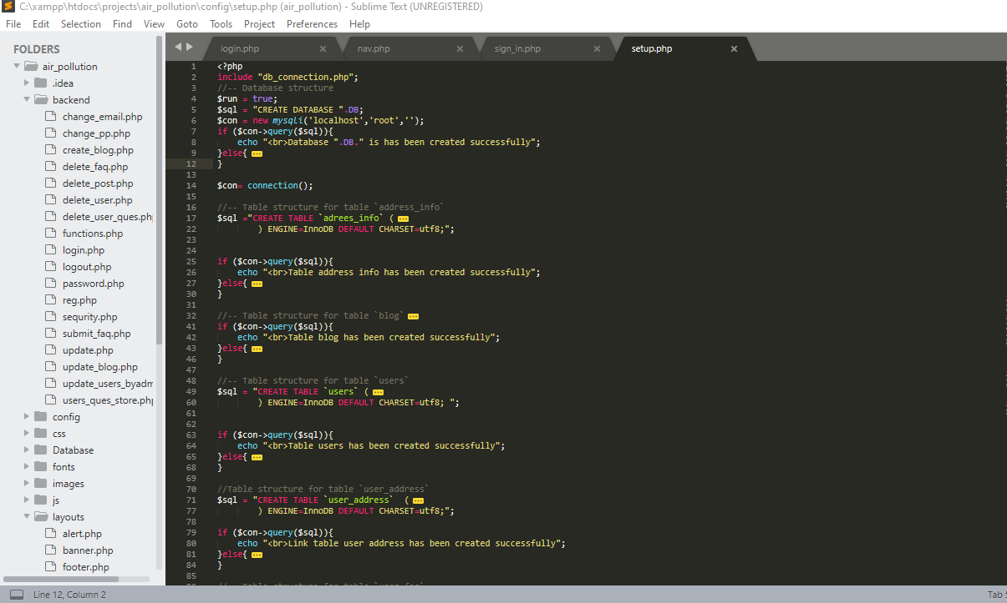

Figure 1: Setup file code

Run setup.php file in config directory if it will run, successfully messages will be show with default admin and admin password. Then click home link to access real application.

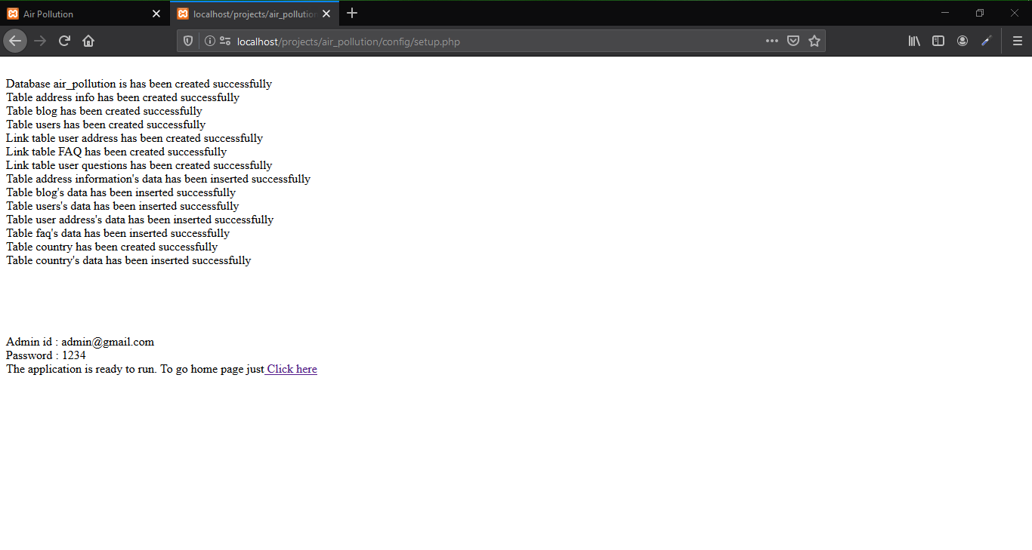

Figure 2: Interface after running setup file successfully.

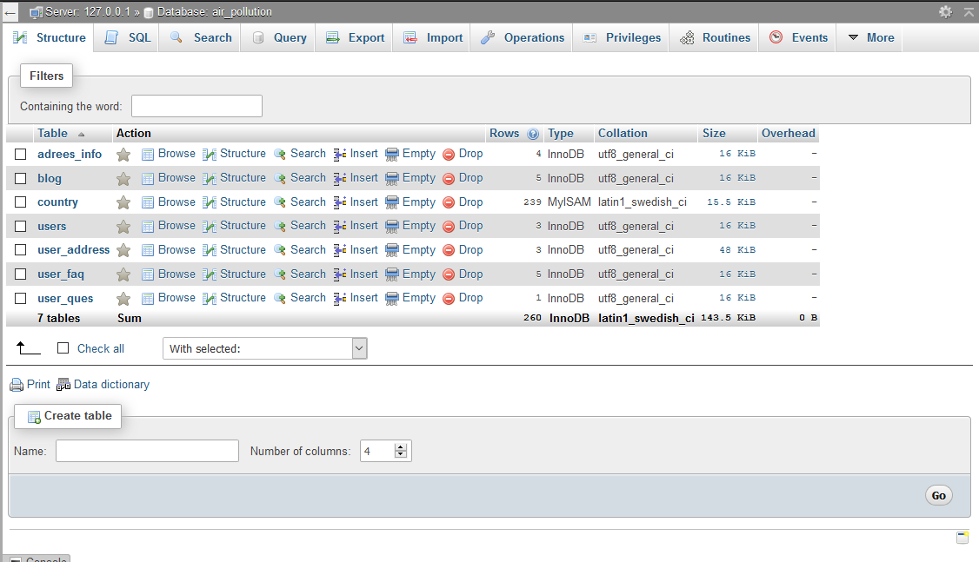

Figure 3: Database and tables for air_pollution application

Home page with clean background with Automatically loading video interface

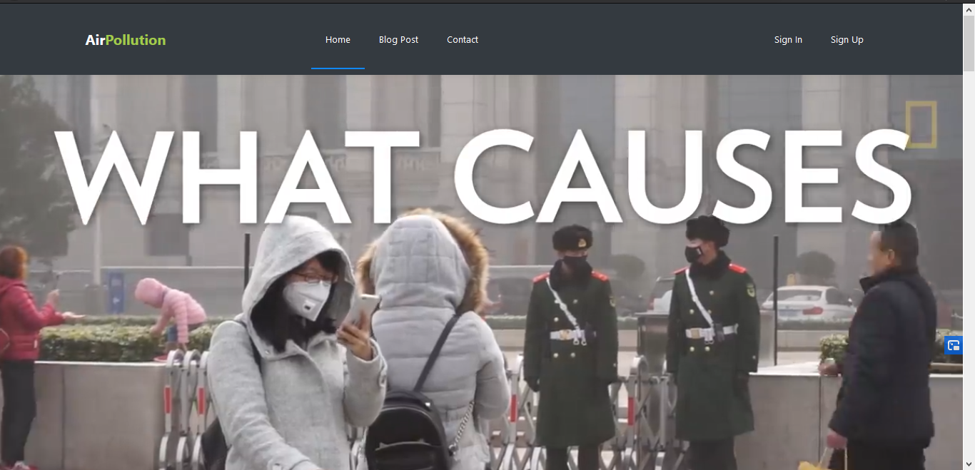

Figure 4: Home page

**Compelling caption against a clean colorful backdrop**

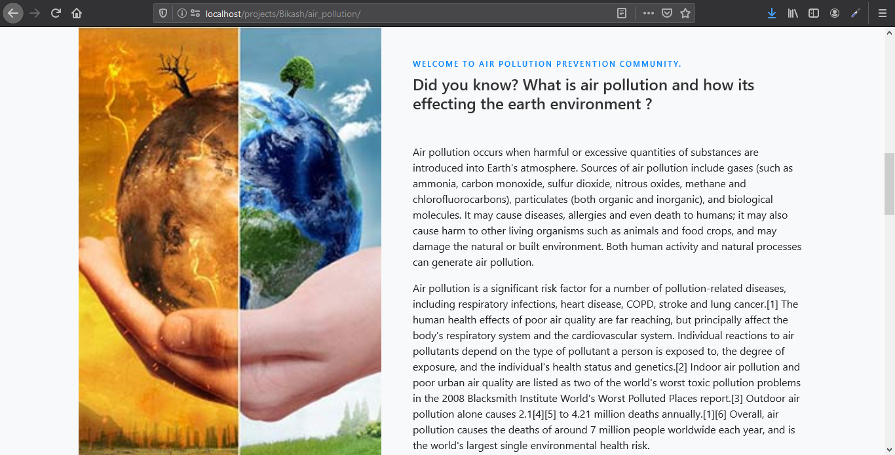

Figure 5:Compelling caption

**Clean colorful backdrop**  
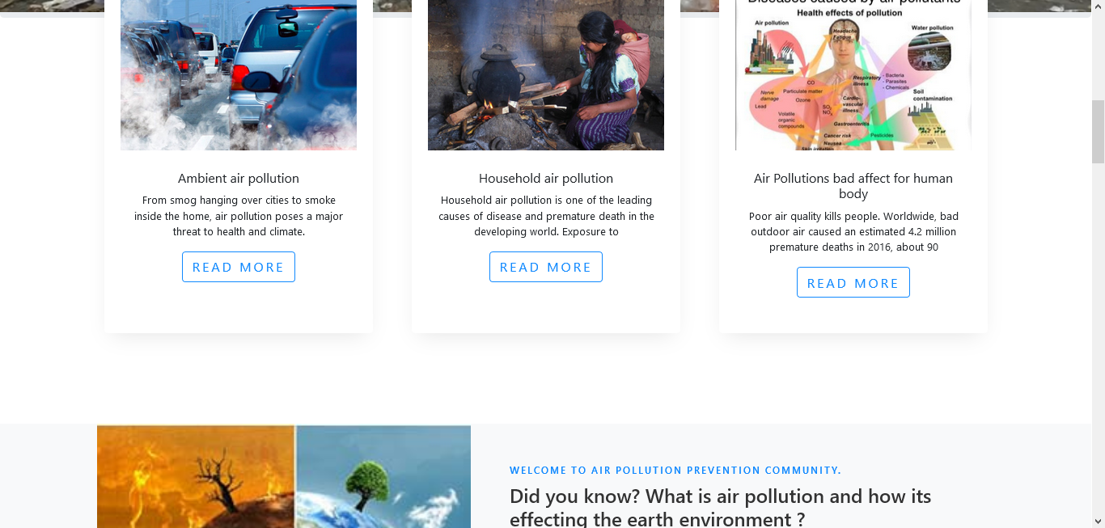

Figure 6:Clean colorful backdrop

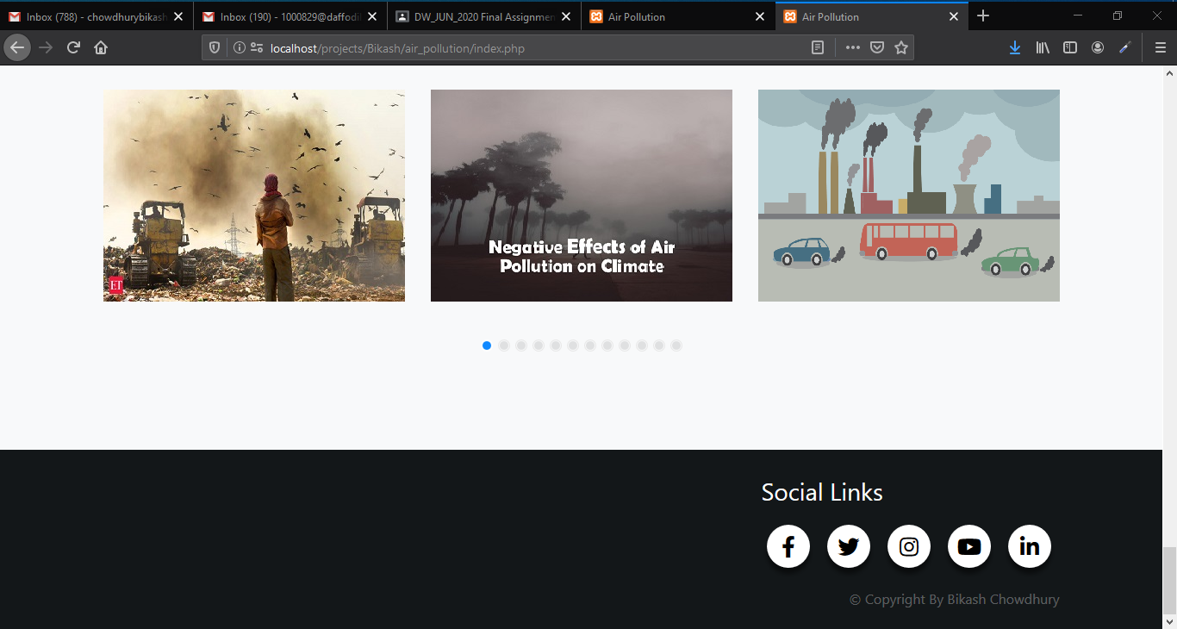

Figure 7: Clean colorful backdrop

**Eye catching images**  
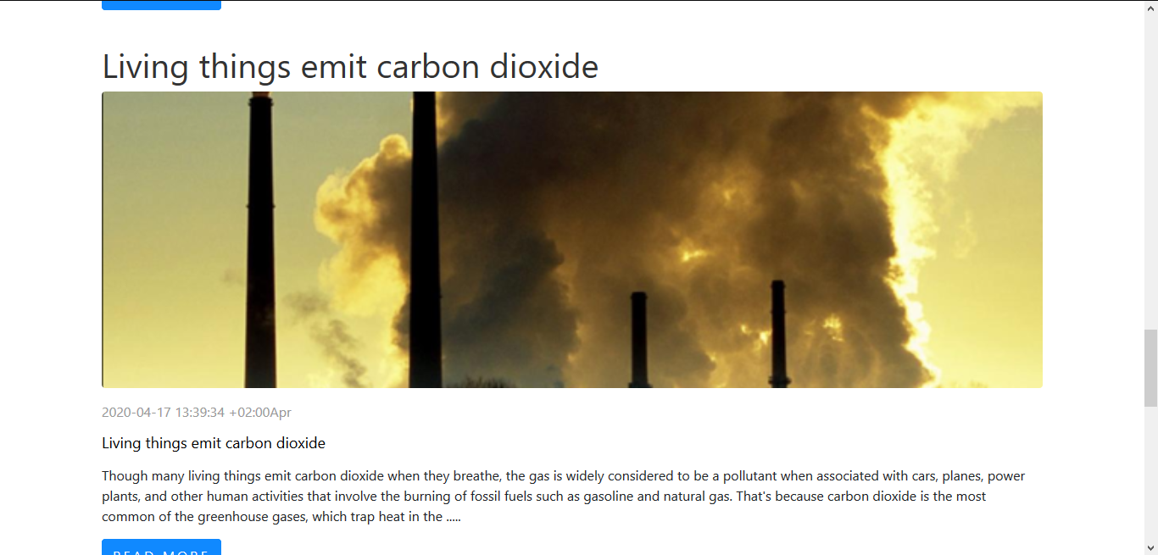

Figure 8:Eye-catching images

## **Scroll-triggered animation will show on home page the page will scrolling**

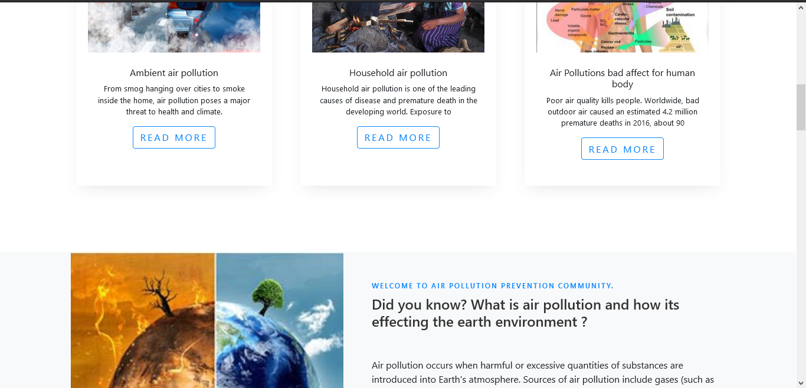

Figure 9: Scroll triggered animation

**Atomically landing video background**  
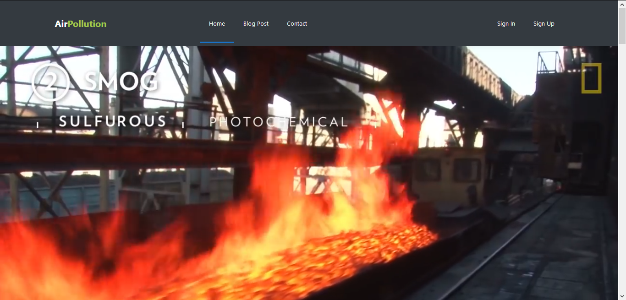

Figure 10:Automatically loading background video

**Fluid layout**  
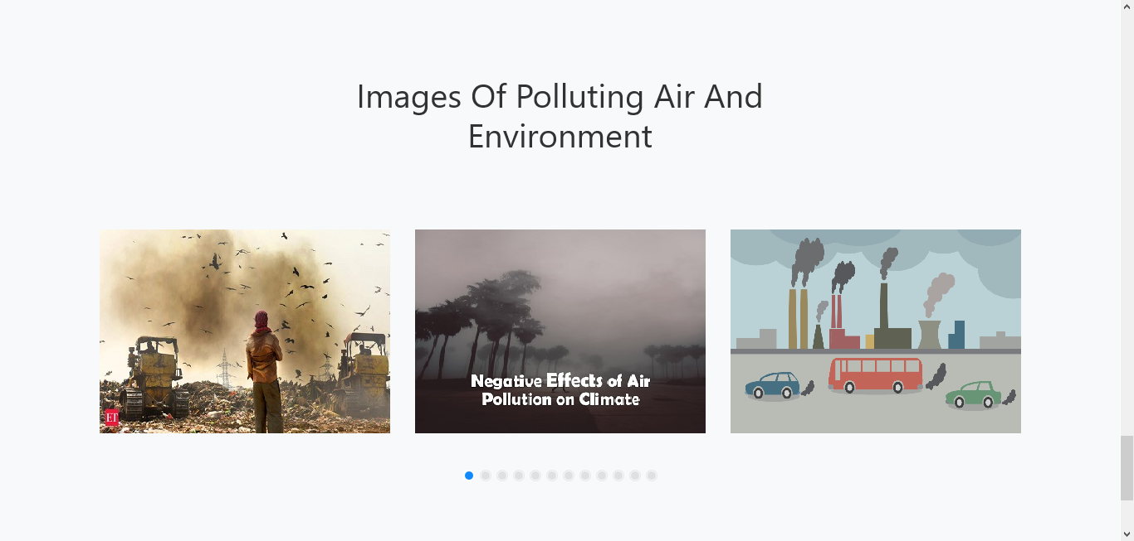

Figure 11:Fluid layout

**Animated/interactive social media buttons**  
Social media animated icon animation is shown by hovering mouse cursor on the icon

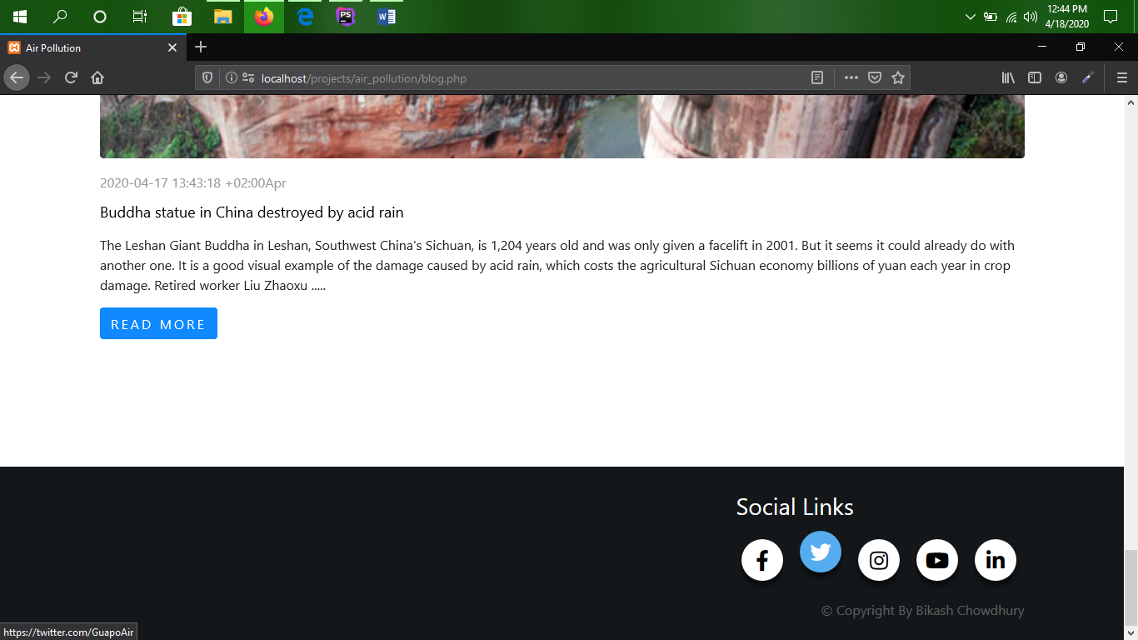

Figure 12:Animated/interactive social media buttons

## **Media links to relevant pollution websites**

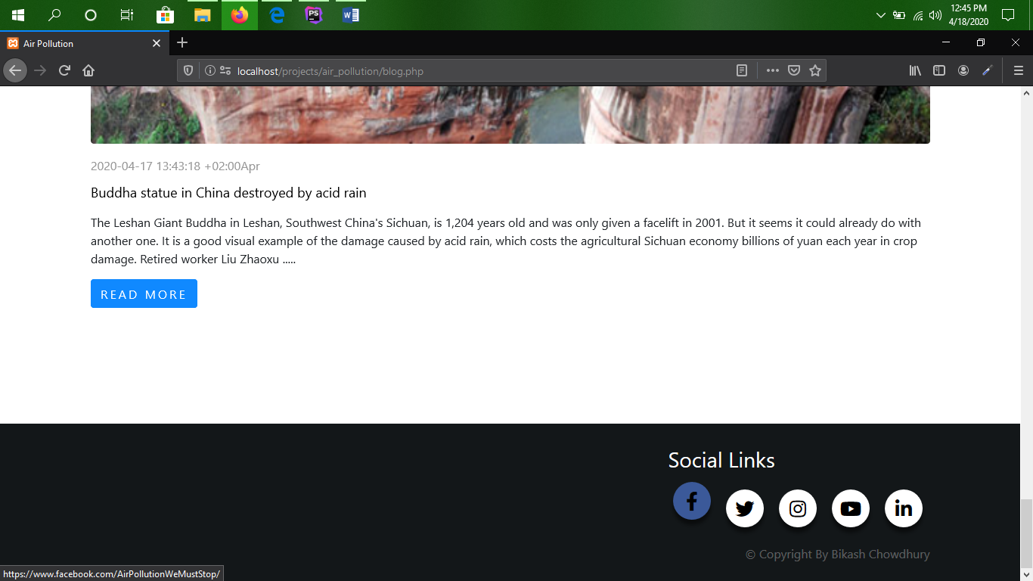

Figure 13: Facebook

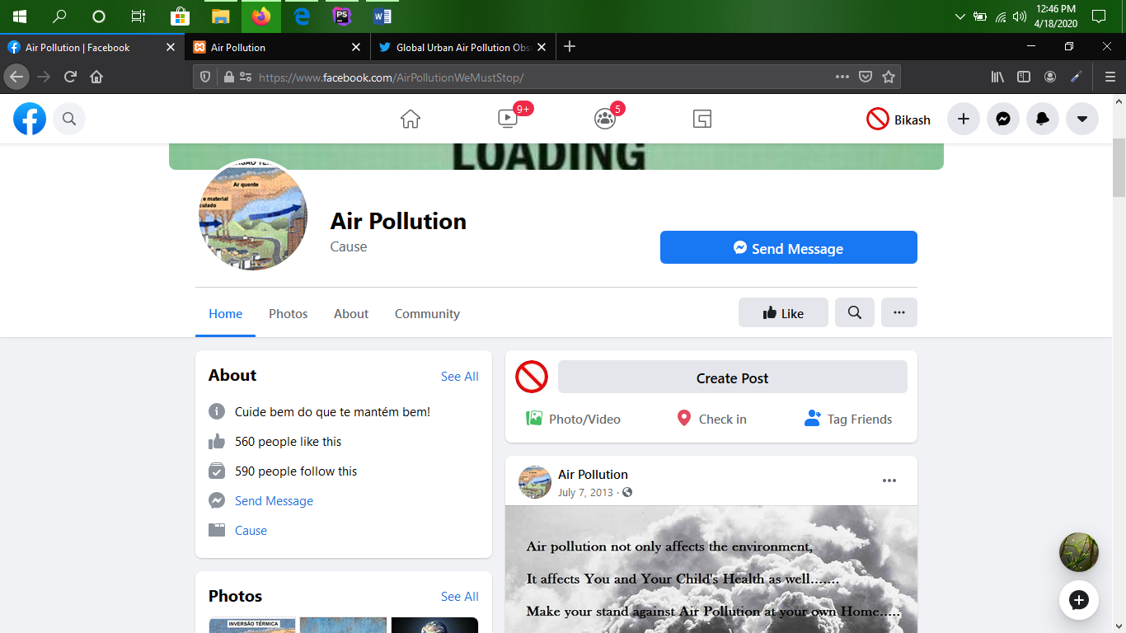

Figure 14: It contain relevant pollution website

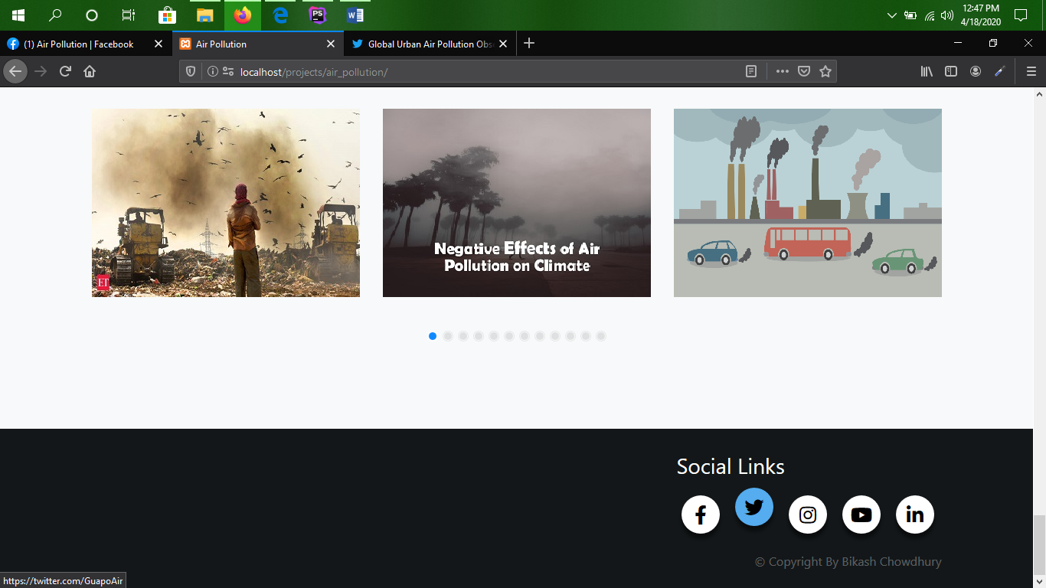

Figure 15: Tweeter

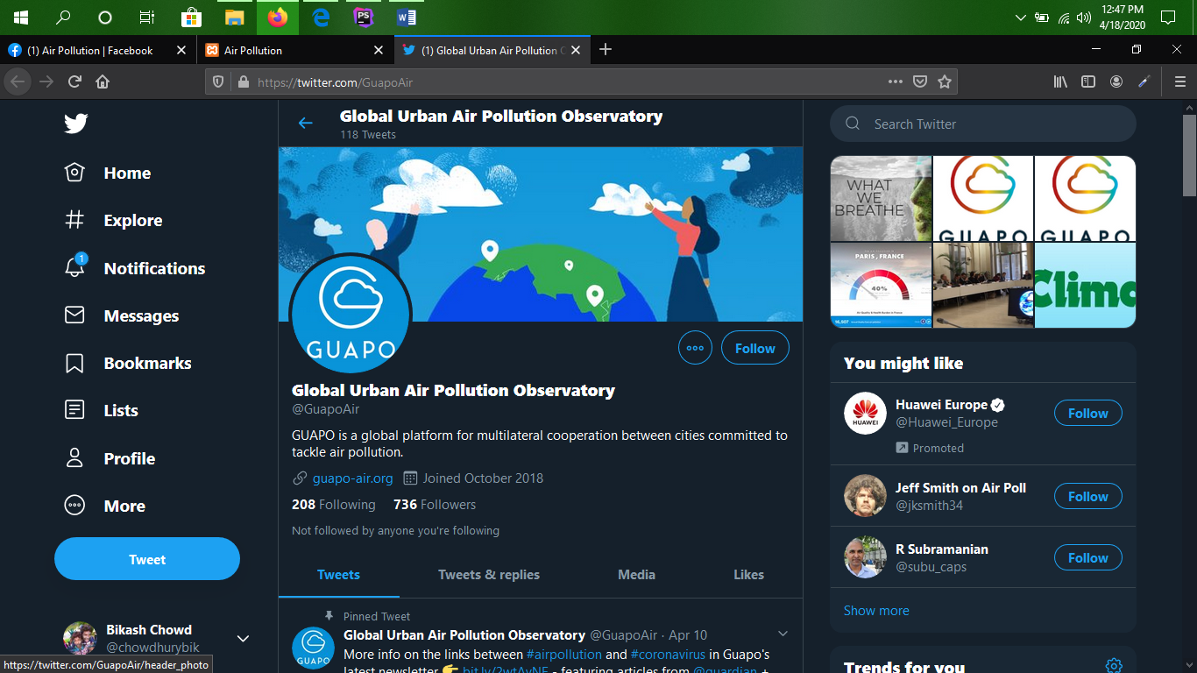

Figure 16: Containing web site over the link

**Action button (sign-up)**

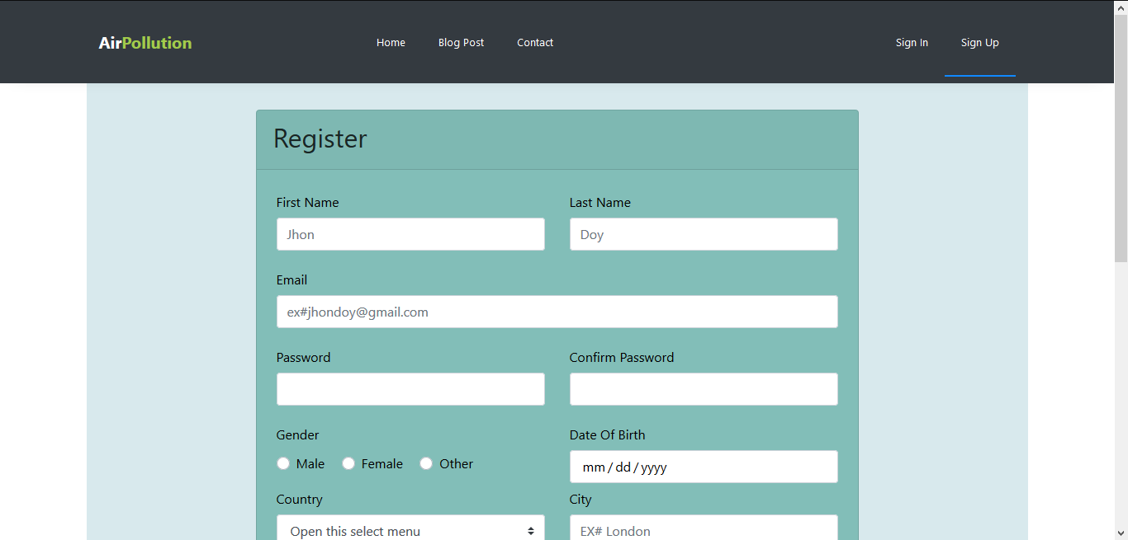

Figure 17:Calling action sign up button

## **An offer of a free home pollution testing kit pop-up**

An offer of a free home pollution testing kit pop-up button for signing up when the customer hovers over the sign-up action button

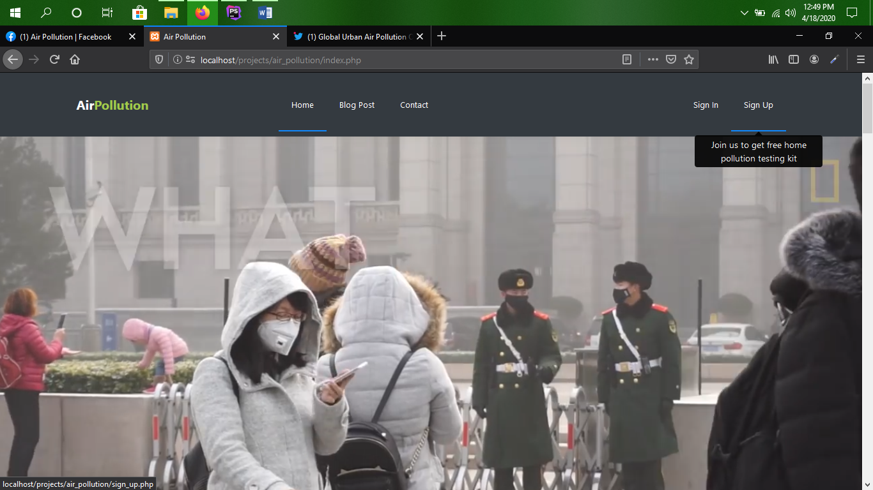

Figure 18: Offer popup

# **Task 2**

## **Login and Registration system including necessary requirements**

When user is not registered or logged in the application will show sign in and sign up button top right corner on the web page.  
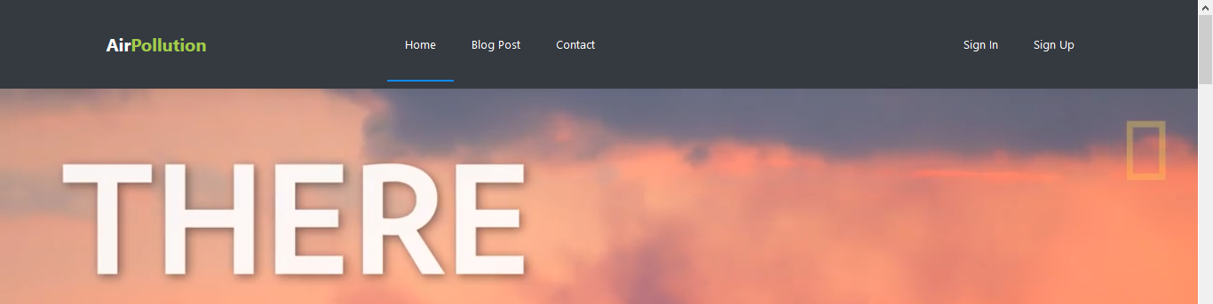

Figure 19: Sing up and sign in button

New user can register by entering sign-up page it will provide a form user must have to fill every field carefully. The form is validated by front end and back end validation.

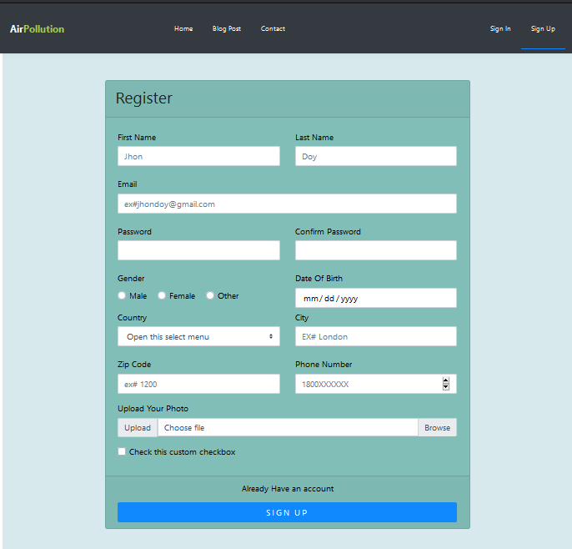

Figure 20: Registration form including all requirements

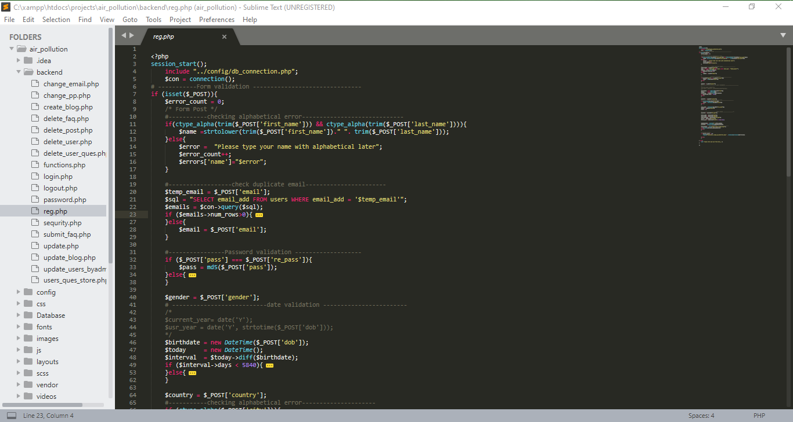

Figure 21: Backend php code with proper validation

## **Password hashing**

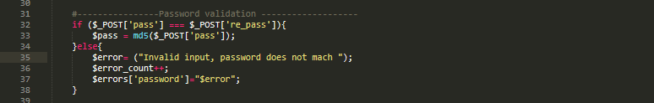

Figure 22: Password hashing

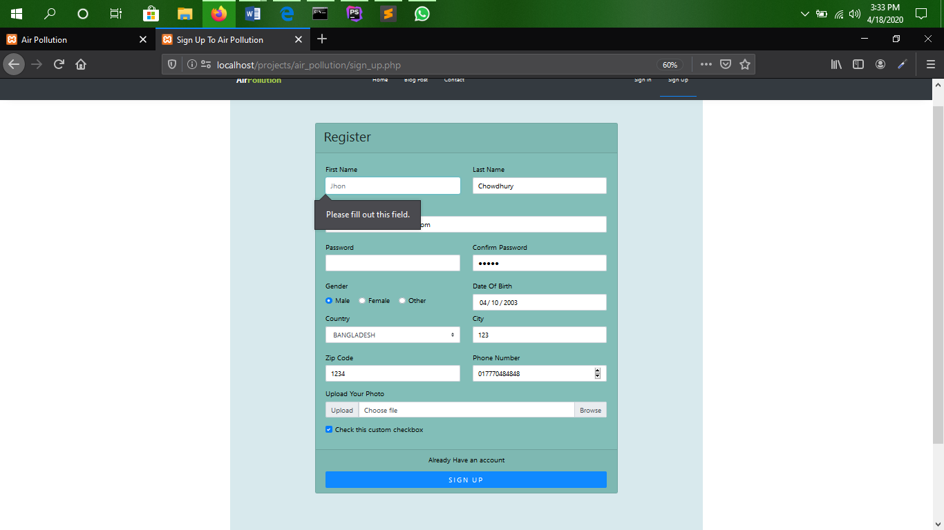

Figure 23: Frontend validation

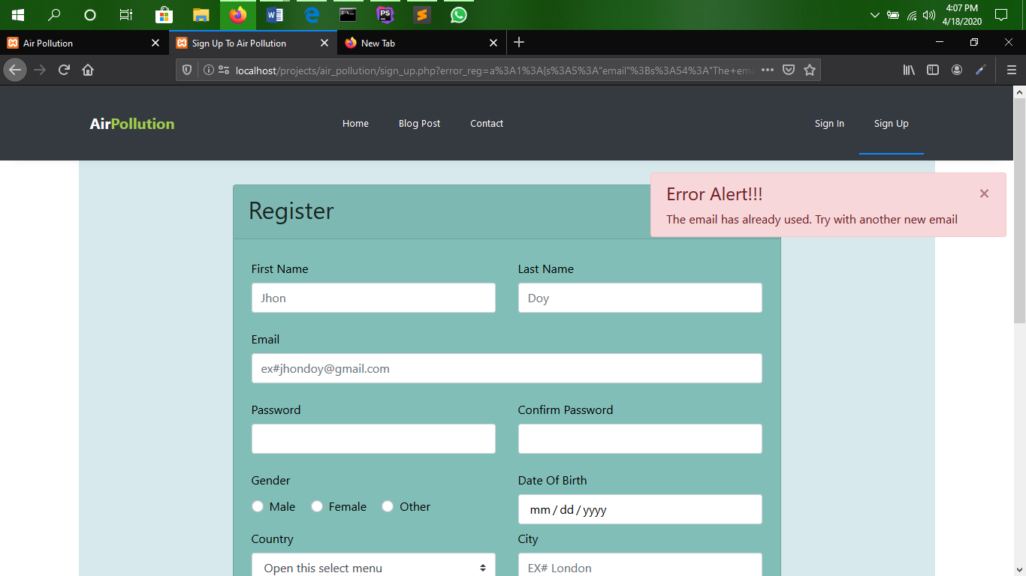

Figure 24: Already used user validation

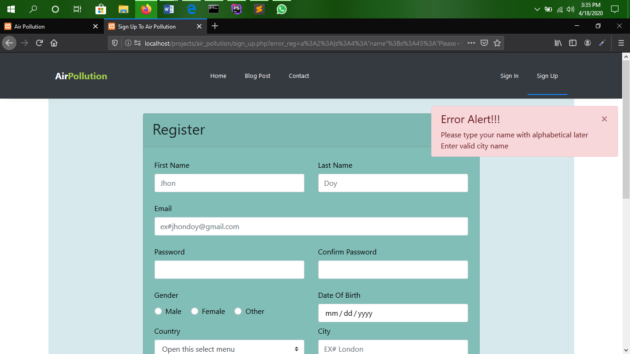

Figure 25: Backend validation popup

After successful registration it will redirect on home page and shown success popup message

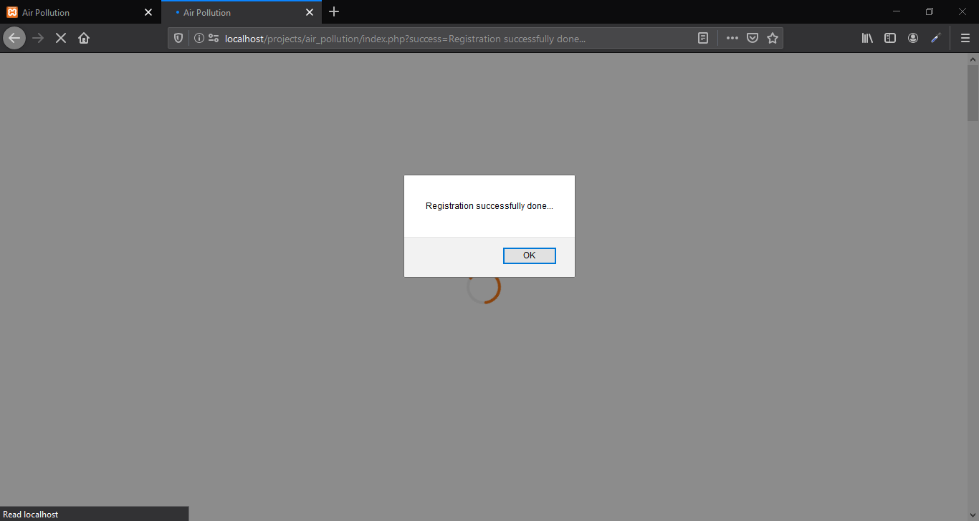

Figure 26: Registration success

After registration user will be automicaly loged in and on the top right corner profile dropdown link will be show.

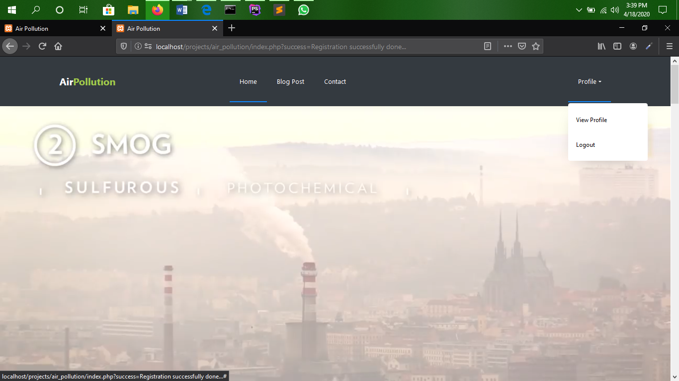

Figure 27: Profile

If user is already registered they can normally log in and access the application

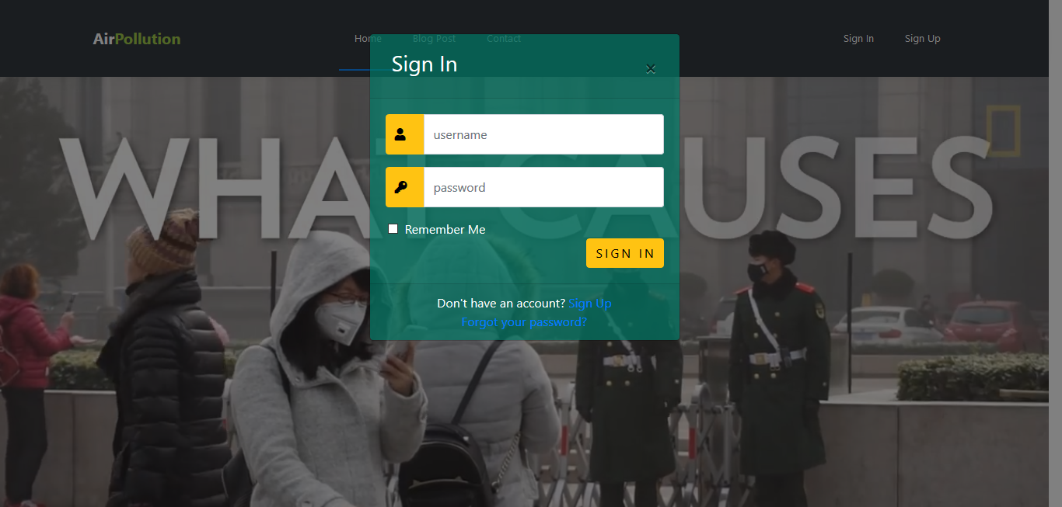

Figure 28: Sign in popup will show on any page

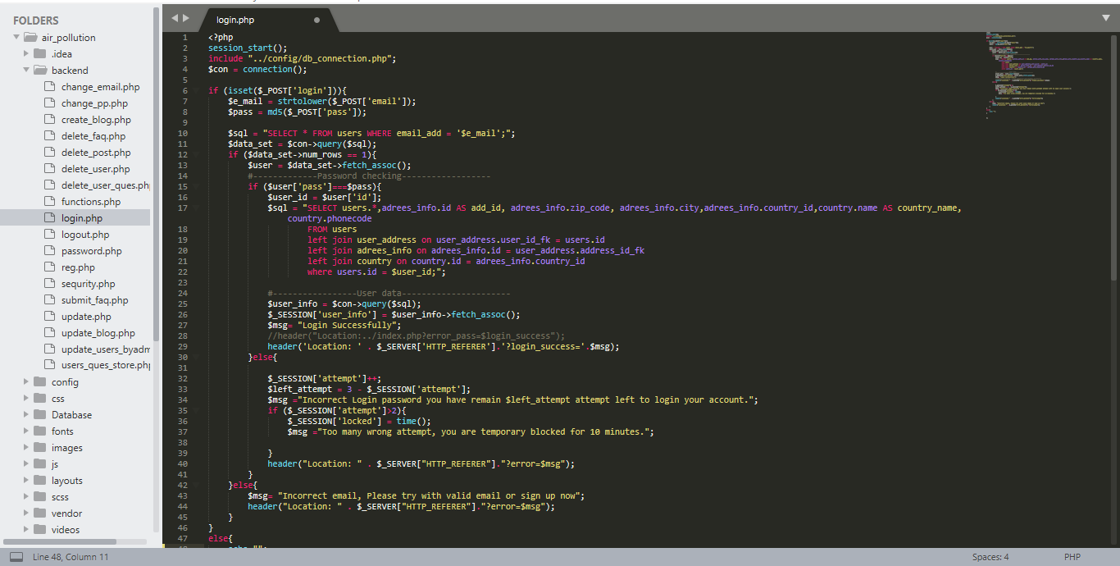

Figure 29: PHP code for login with proper validation

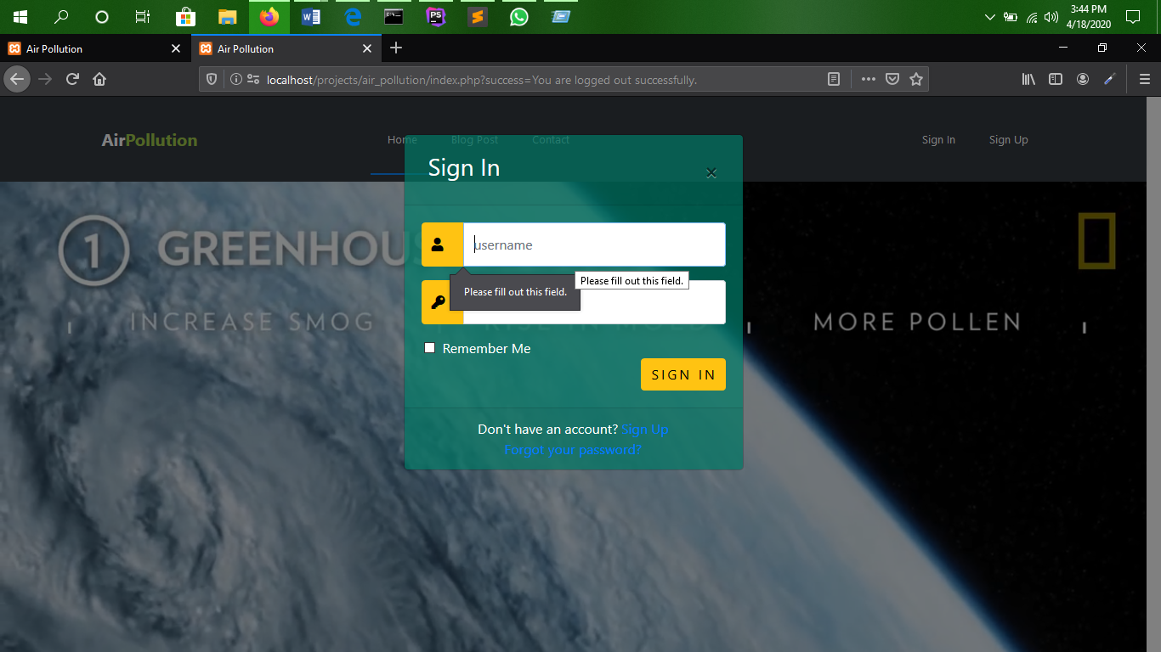

Figure 30:Frontend login validation

## **Incorrect unreregisterd email checking alert**

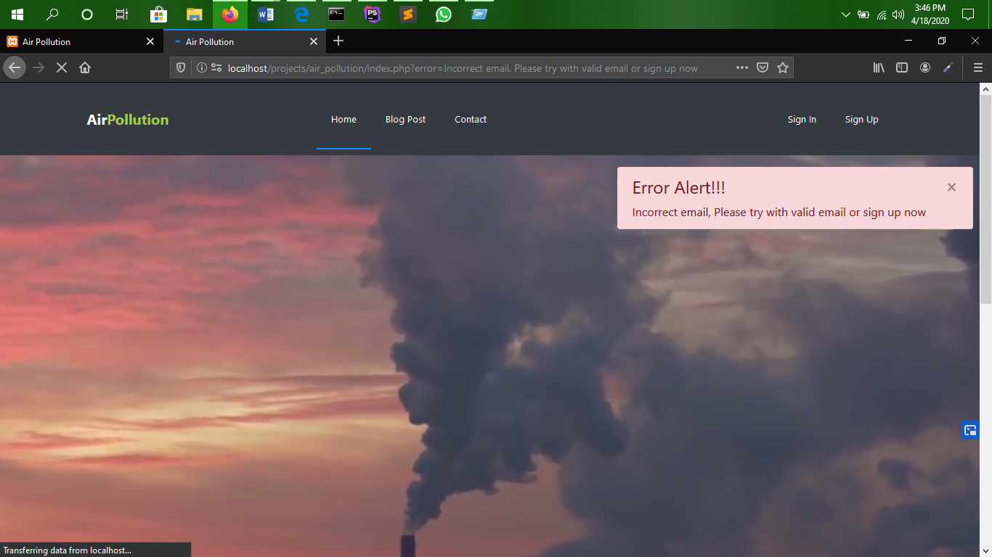

Figure 31:Backend login Validation

## **Wrong password attempting alert and locking account for 10 minutes**

Over three times incorret login password will temporary block user to sign in for 10 minutes for sequrity purpose

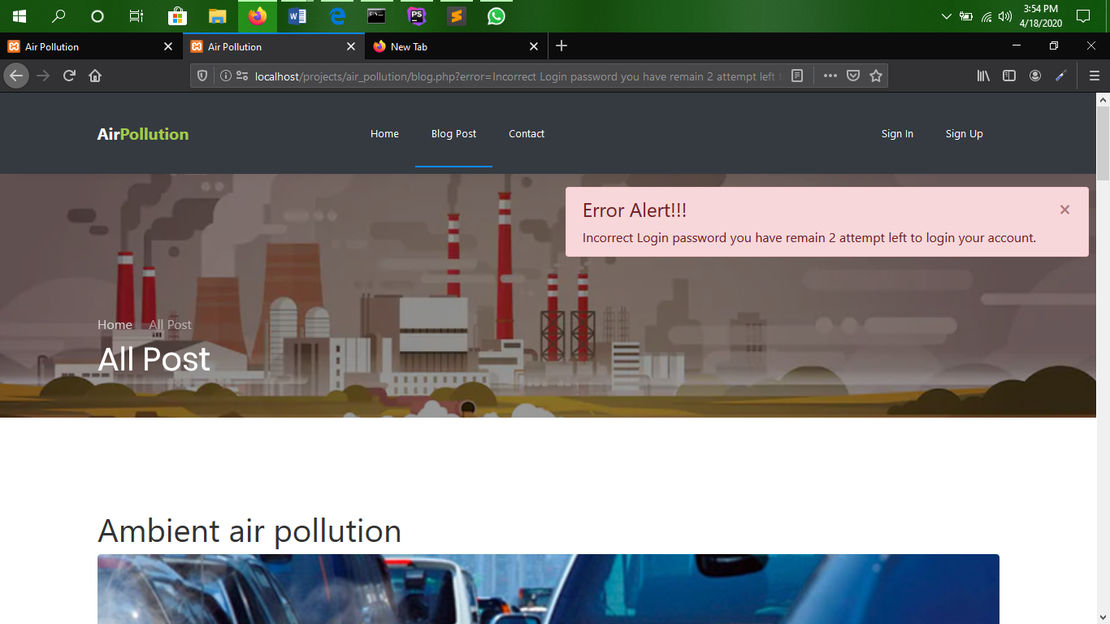

Figure 32: Incorrect password login attempt

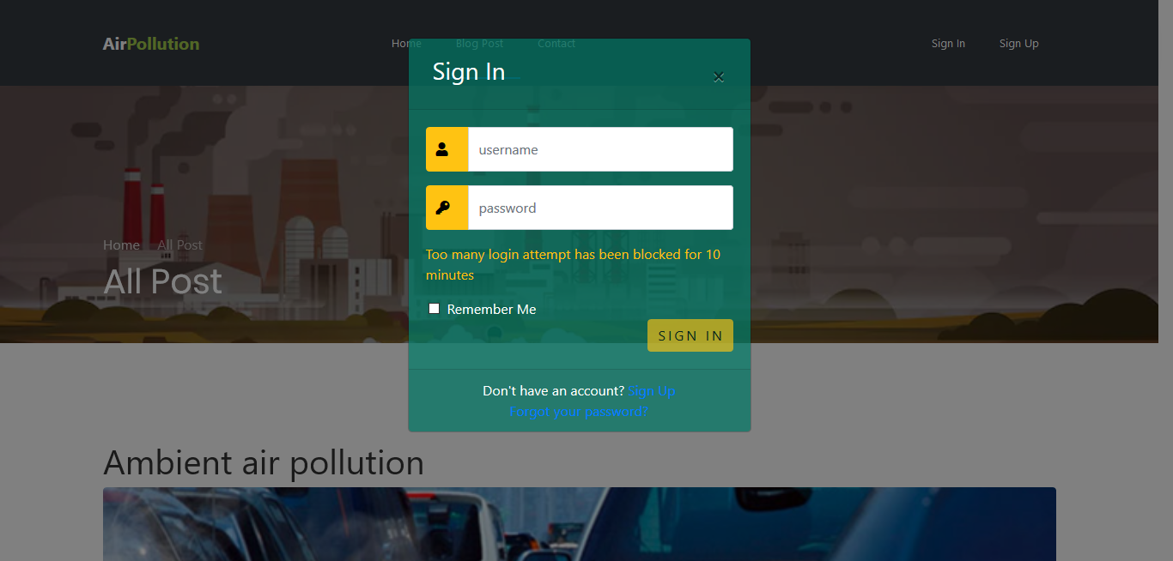

Figure 33: blocked for 10 minutes

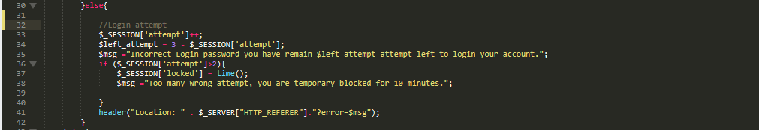

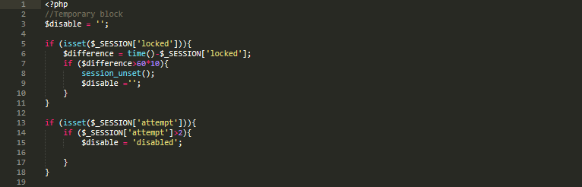

Figure 34:Code for login attempt checker

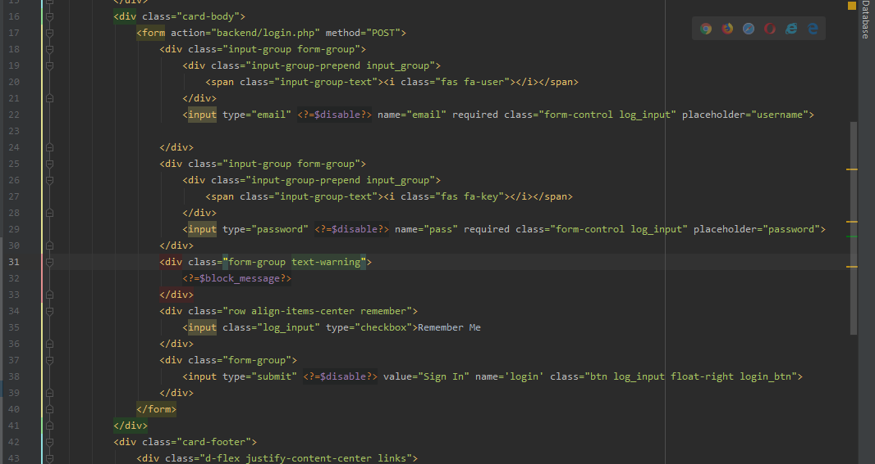

Figure 35: Login form code

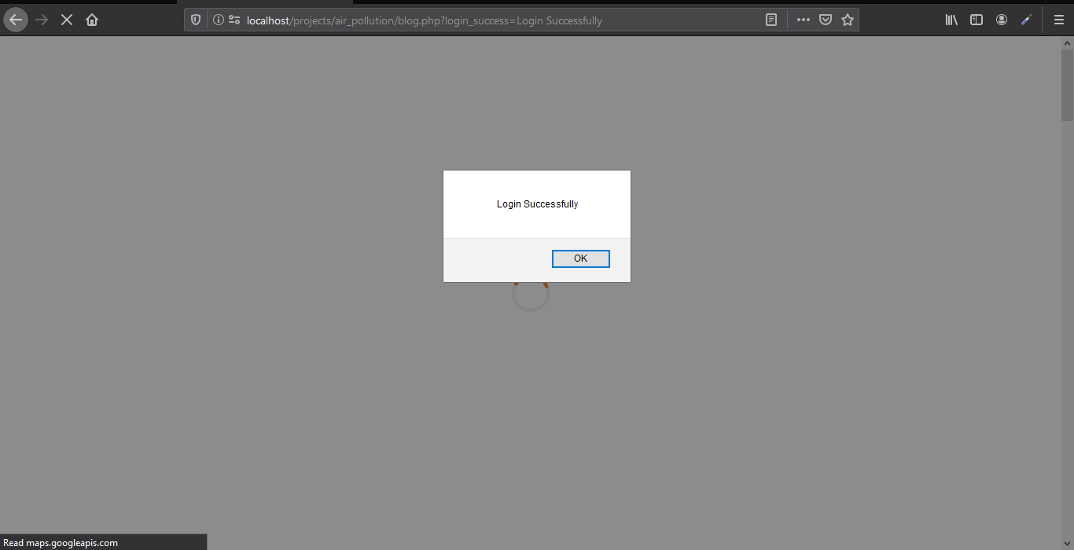

Figure 36: Successfully login alert

# **Task 3**

## **Logged on users can access their account**

Once the users have logged on they can access to their account by accessing profile dropdown link. They can edit, and change their personal data. They also can change their email and password. Everything is validated by frontend and backend checking.

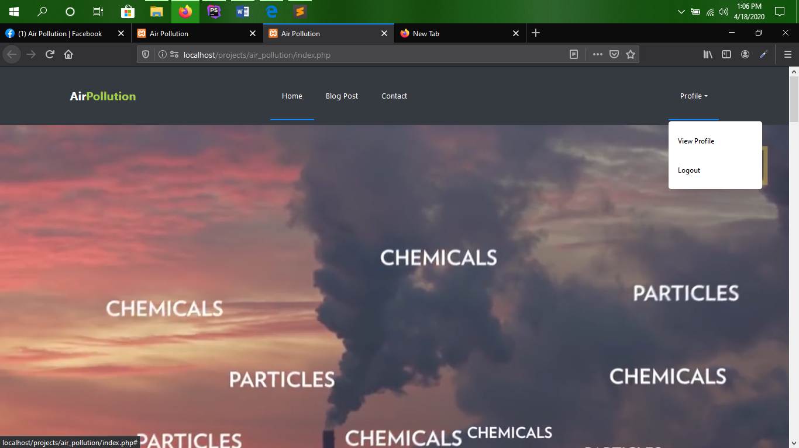

Figure 37: Profile Link

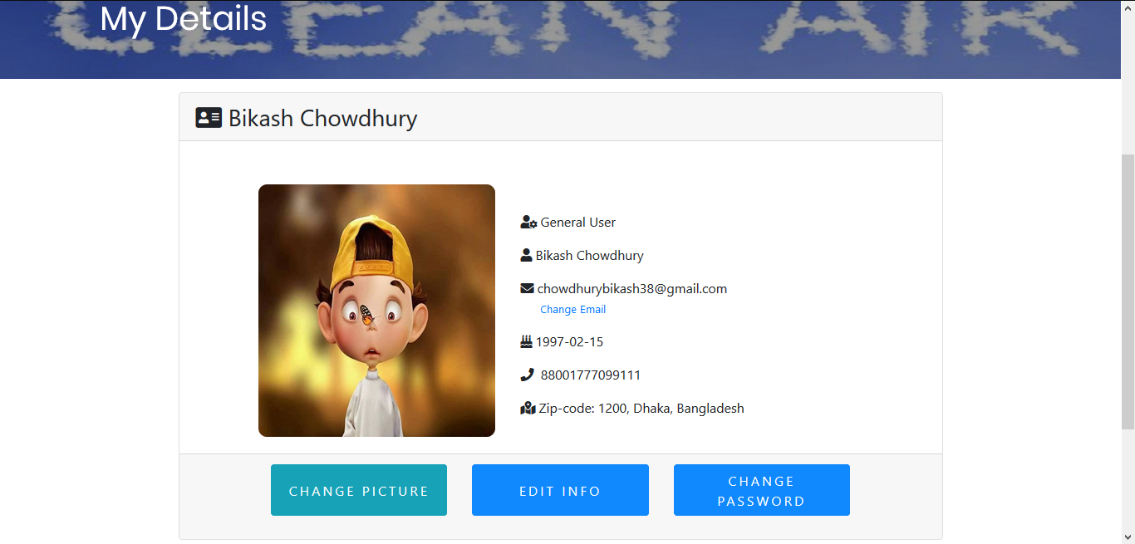

Figure 38: User profile information

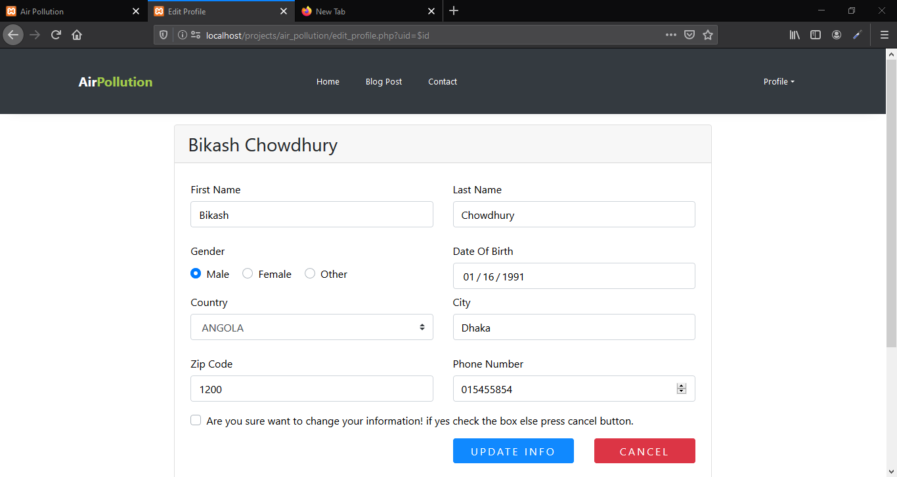

Figure 39: user information changing interface

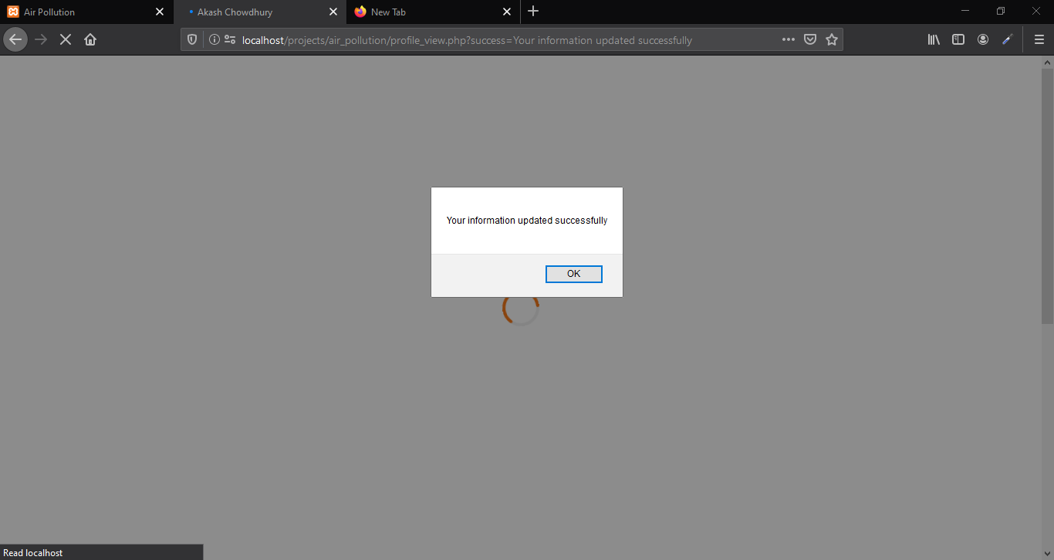

Figure 40: success alert

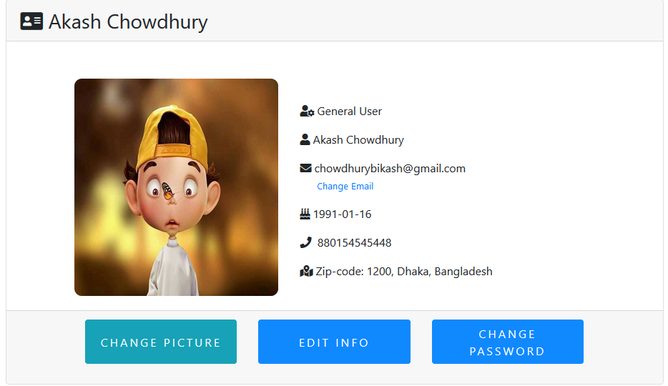

Figure 41: After update information

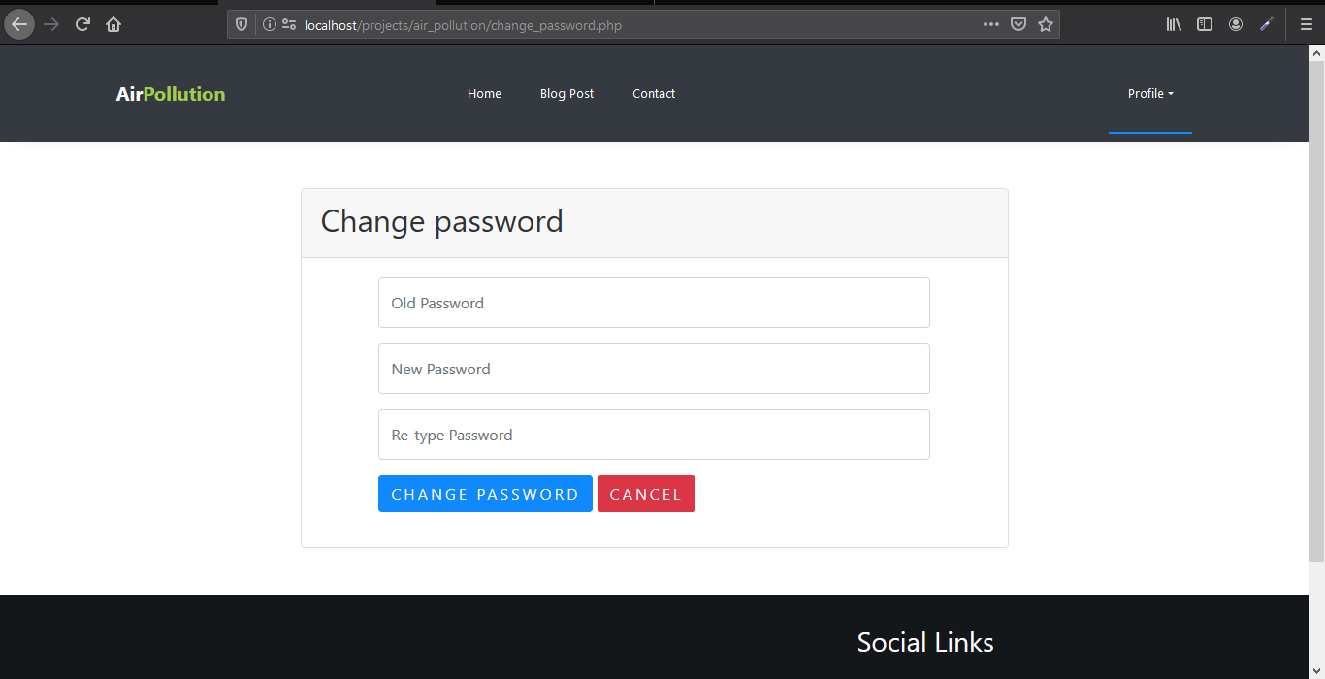

Figure 42: Password changing

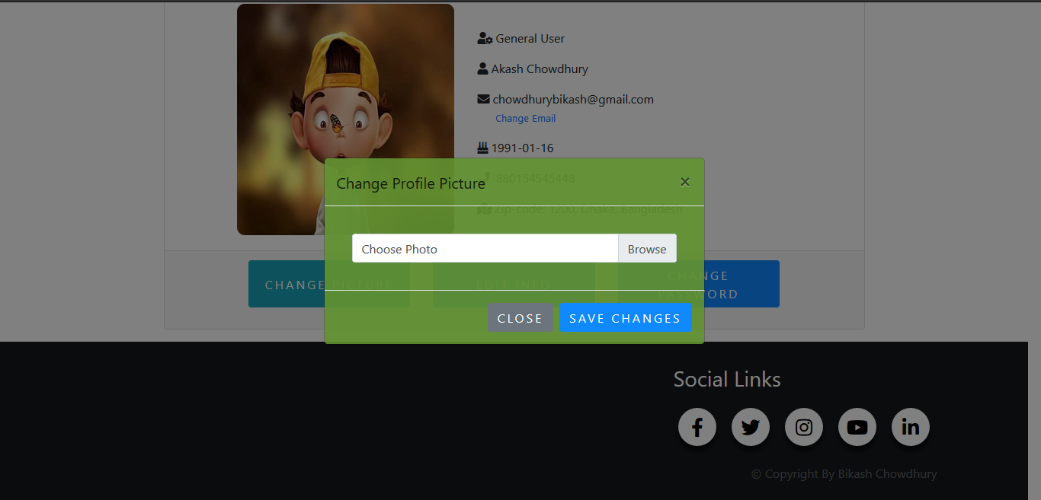

Figure 43: picture changing

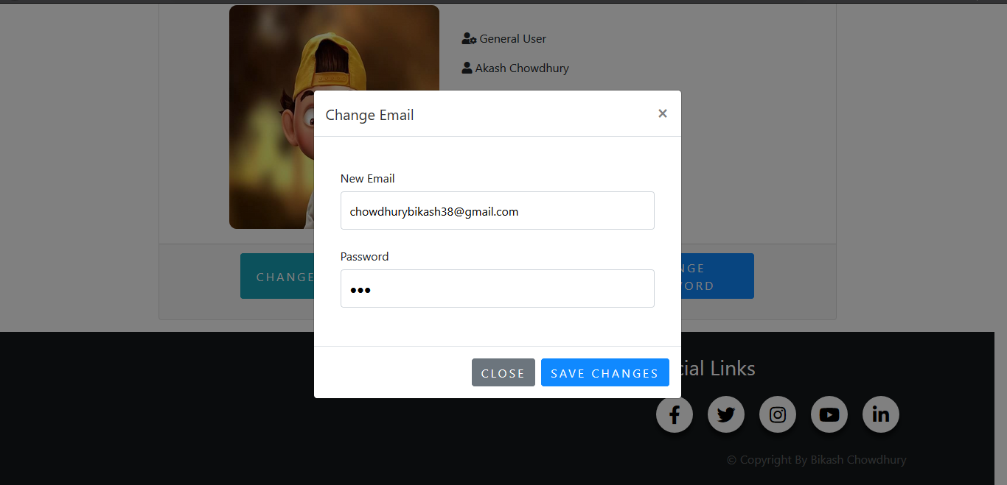

Figure 44: email changing

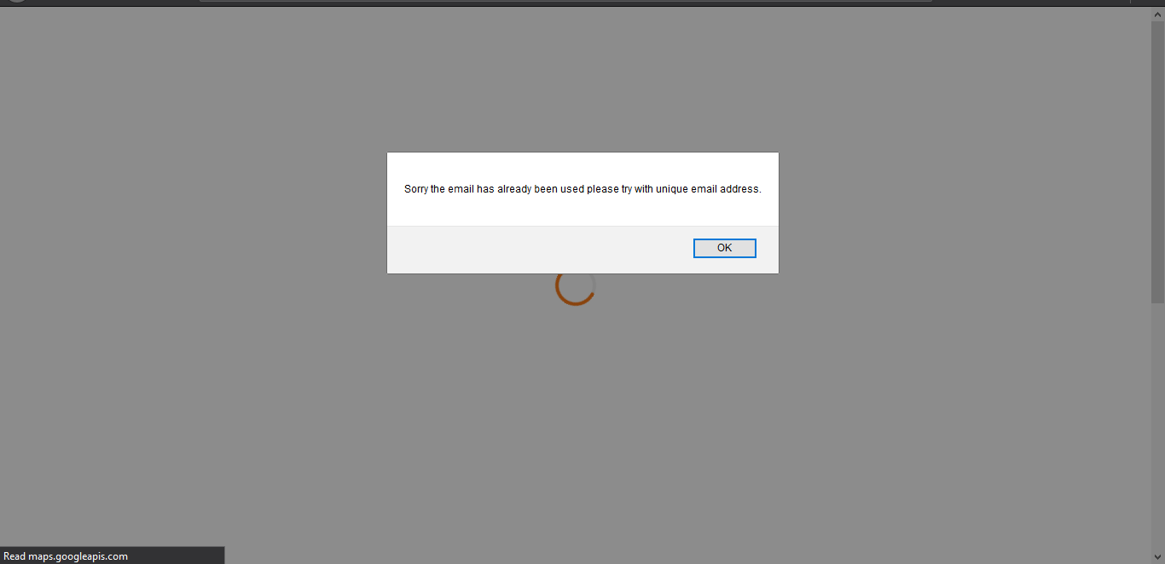

Figure 45: Duplicate email validation

## **“contact us” form where customers can ask questions including FAQ popup message**

User can contact and asking something by using contact us form. It will also show some FAQ answers when the user will click send button. User can dismiss submitting form if they are satisfied by reading FAQ else they can confirm it sending from.

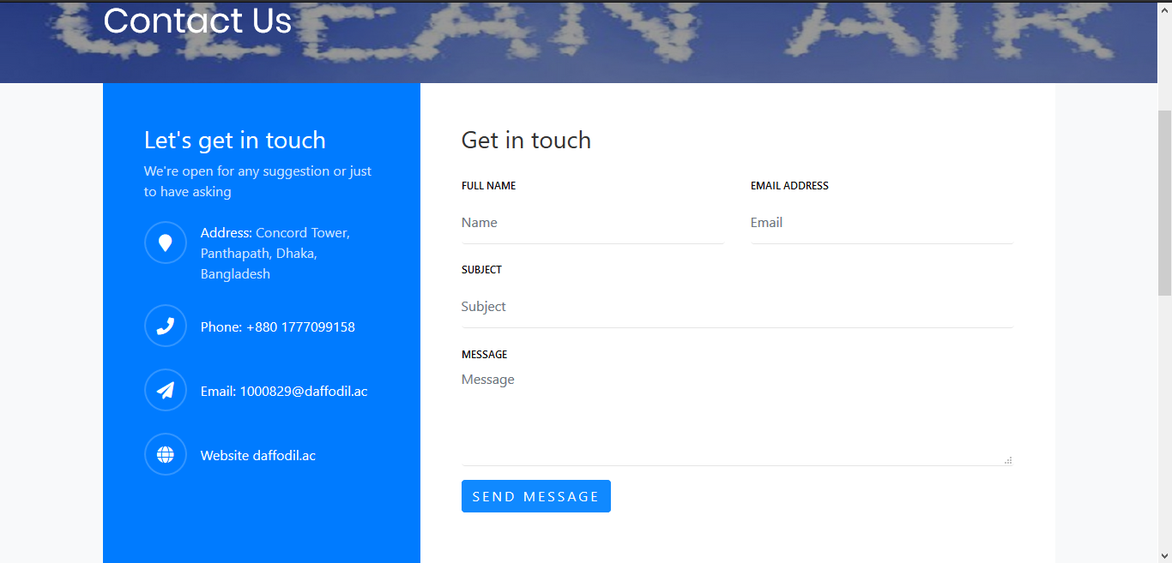

Figure 46: Contact us form

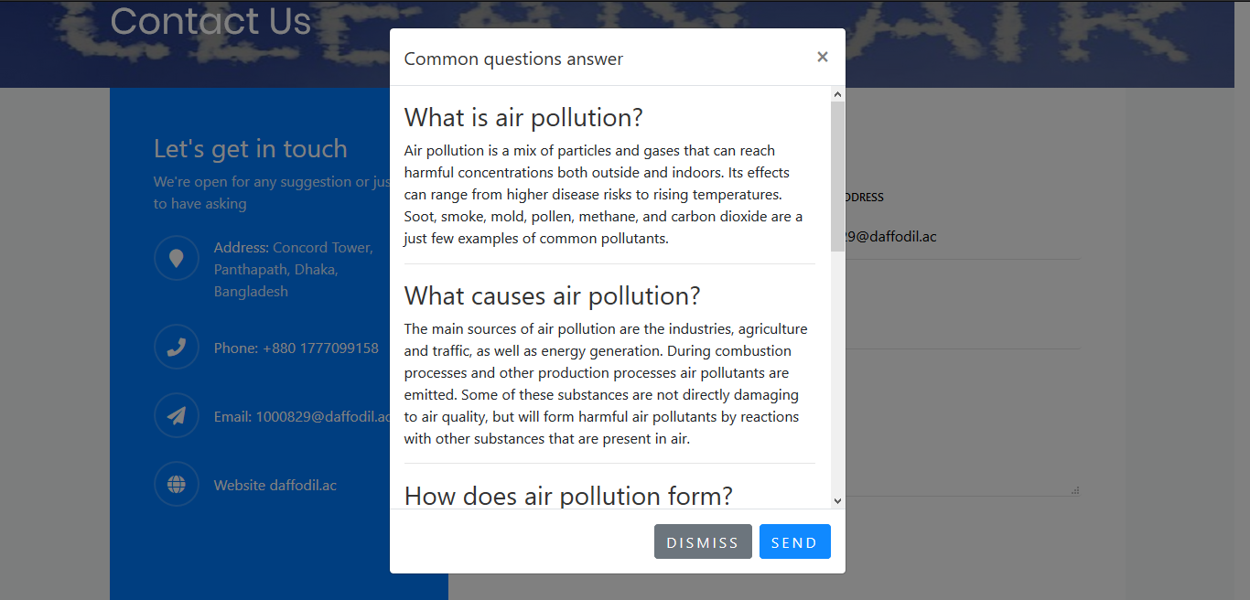

Figure 47: FAQ

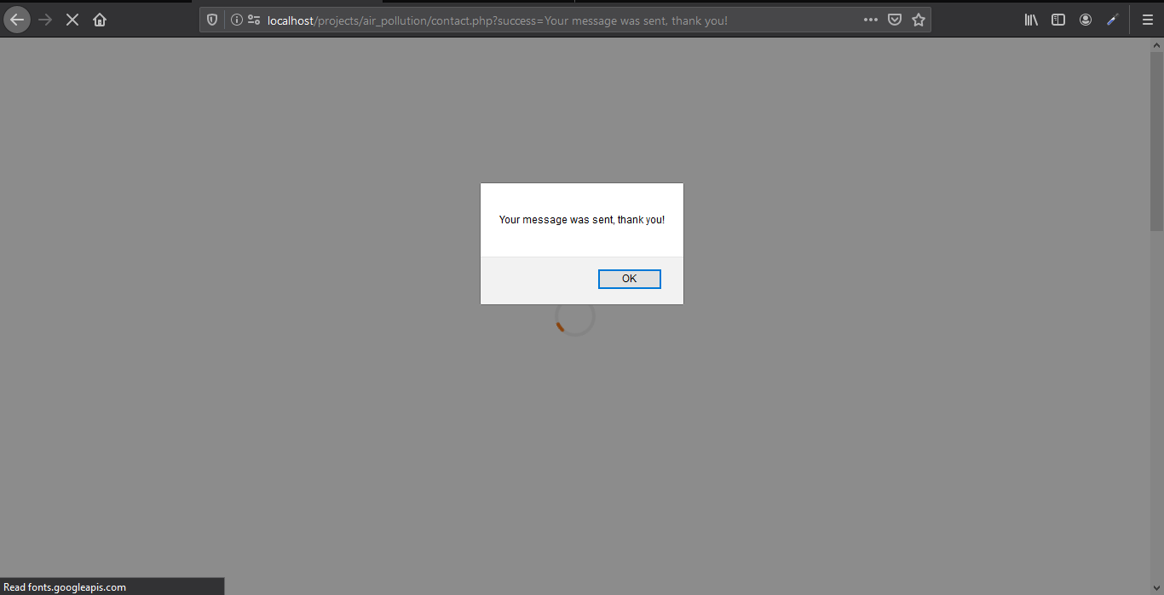

Figure 48:Sending success alert

# **Task 4**

## **Mobile accessible website on phone/tablet**

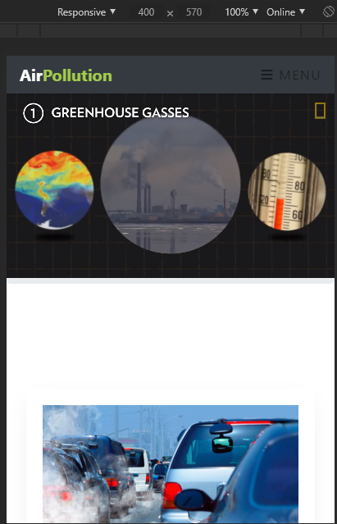

Figure 49: Mobile view home page

## **Suitable use of a web service**

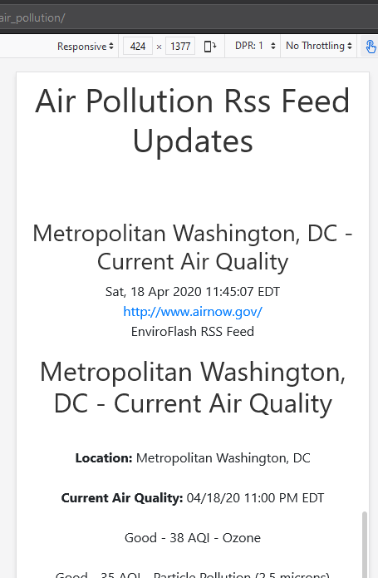

Figure 50: Suitable uses of web services

**Responsive/adaptive pages**  
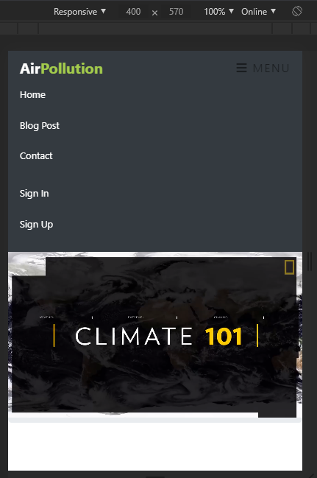

Figure 51:Suitable use of a web service

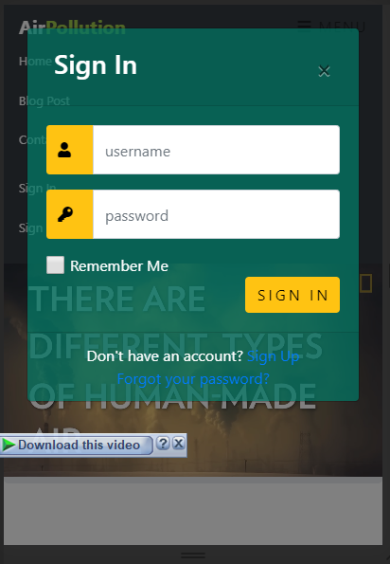

Figure 52: Mobile view responsive form

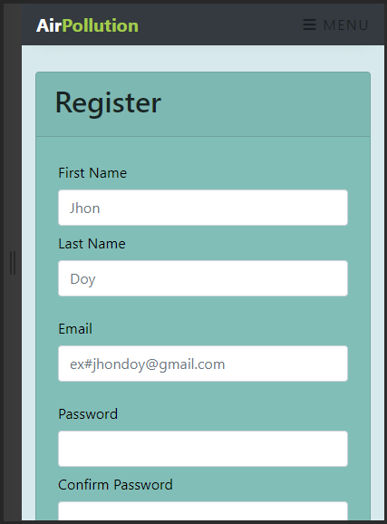

Figure 53: Mobile view registration form

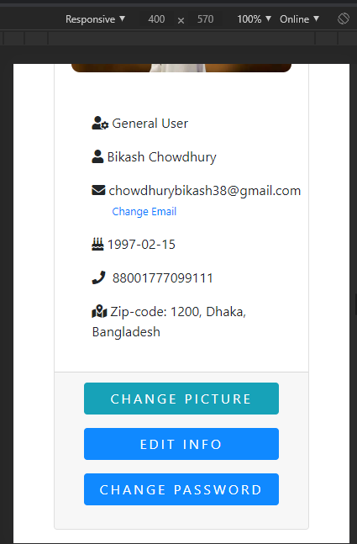

Figure 54: Responsive user profile

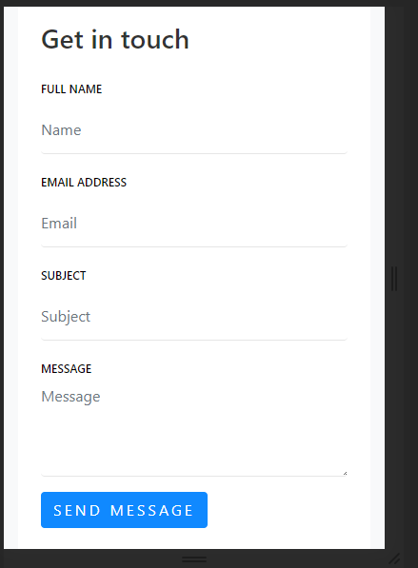

Figure 55:Responsive/adaptive pages based on user needs

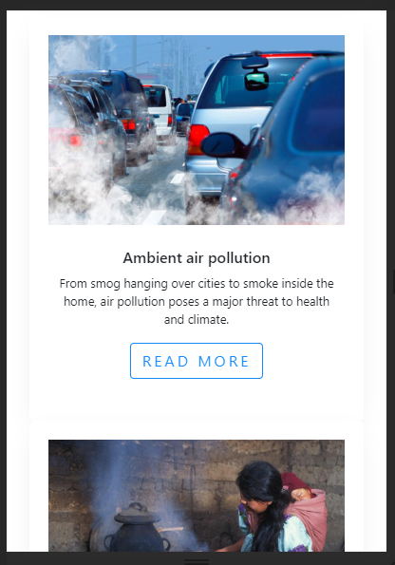

Figure 56: Responsive view

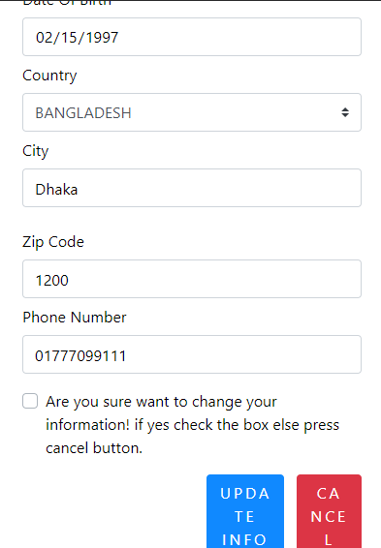

Figure 57: Mobile view

## **The city name to the landing page header as a personal touch**

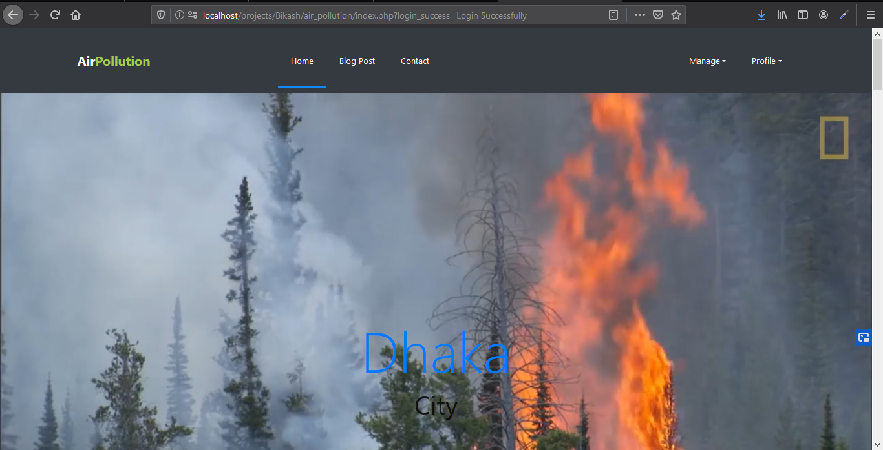

Figure 58: RSS feed of live update of air pollution

## **Task 5**

User have ability to create and query their personal data which is shown in task 3 and user also can read every post if they want by using read more button. And it has an additional feature for admin. Admin can access and organize the web interface. The admin has also ability to see user data and also can change it.

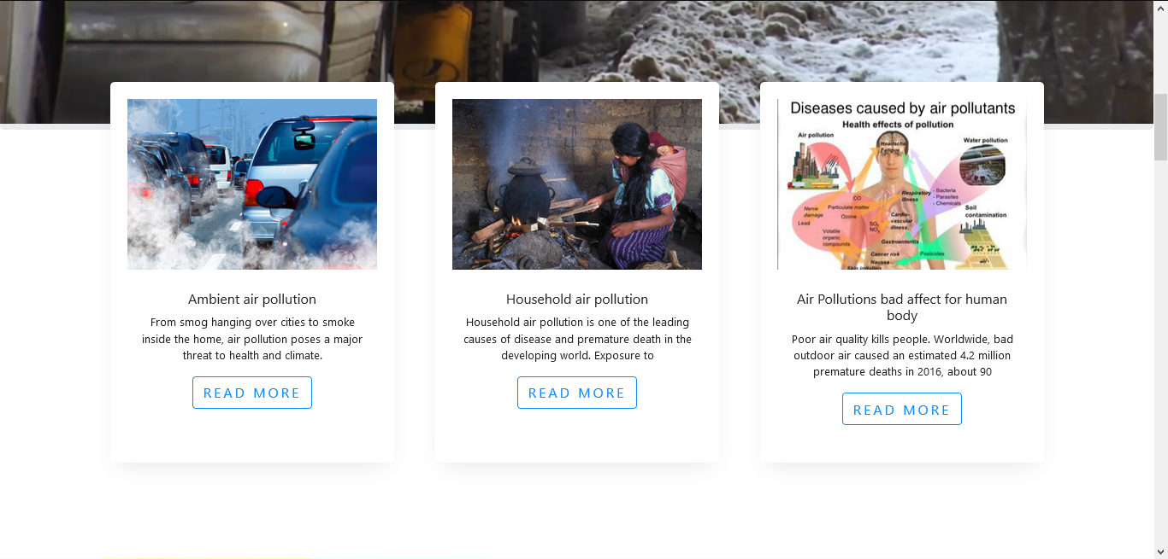

Figure 59: Short post

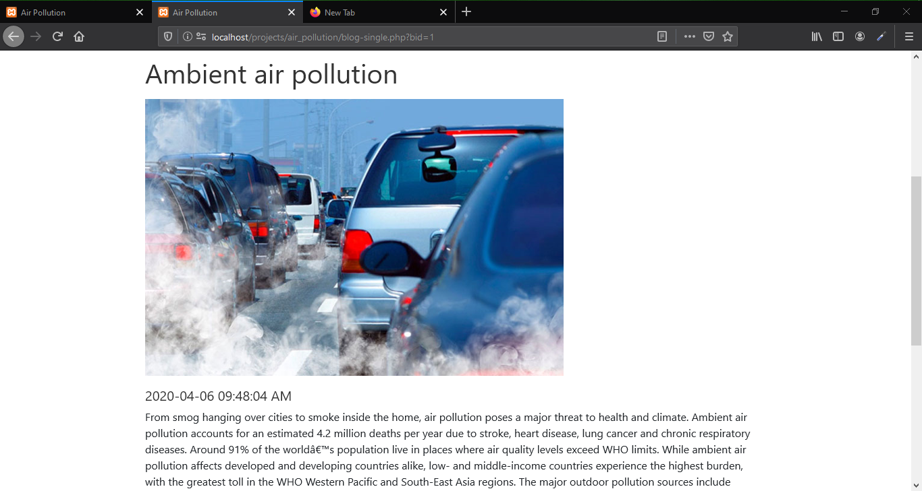

Figure 60: Post with details

## **Additional features for admin users control**

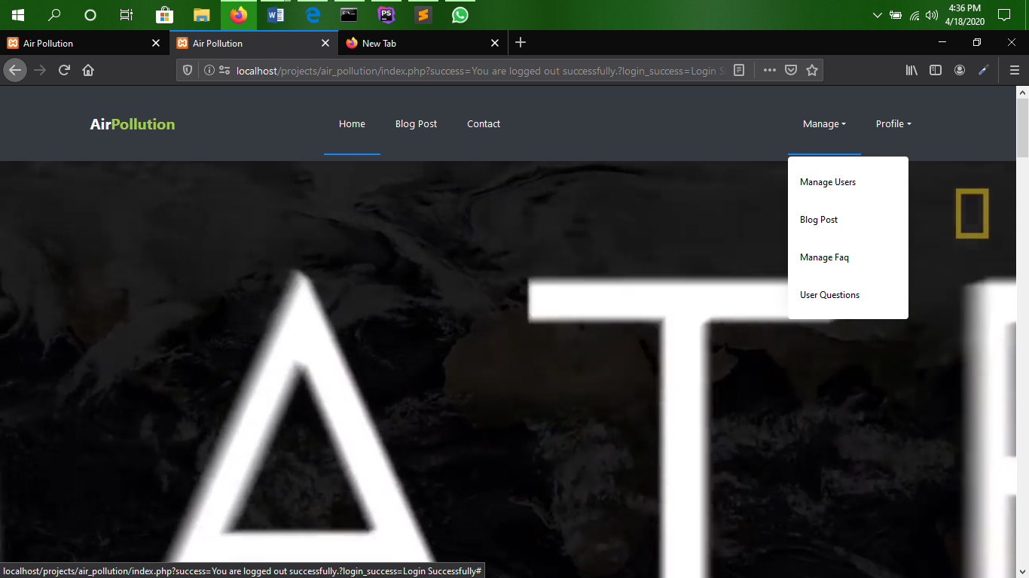

Figure 61:Additional manage dropdown link for admin

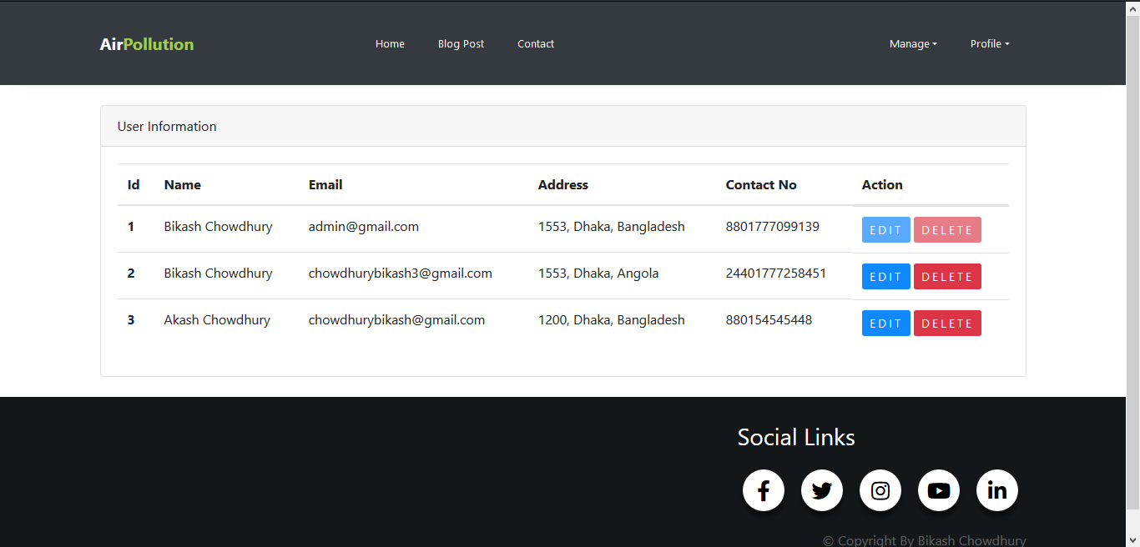

Figure 62: All users

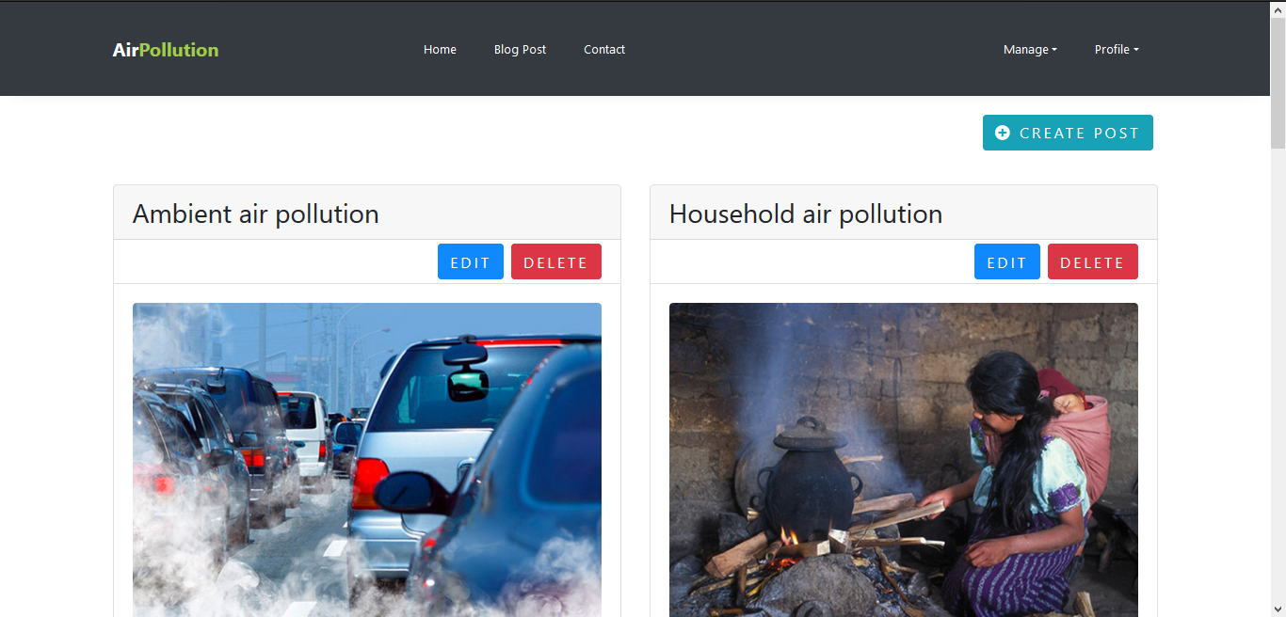

Figure 63: Can create and access post

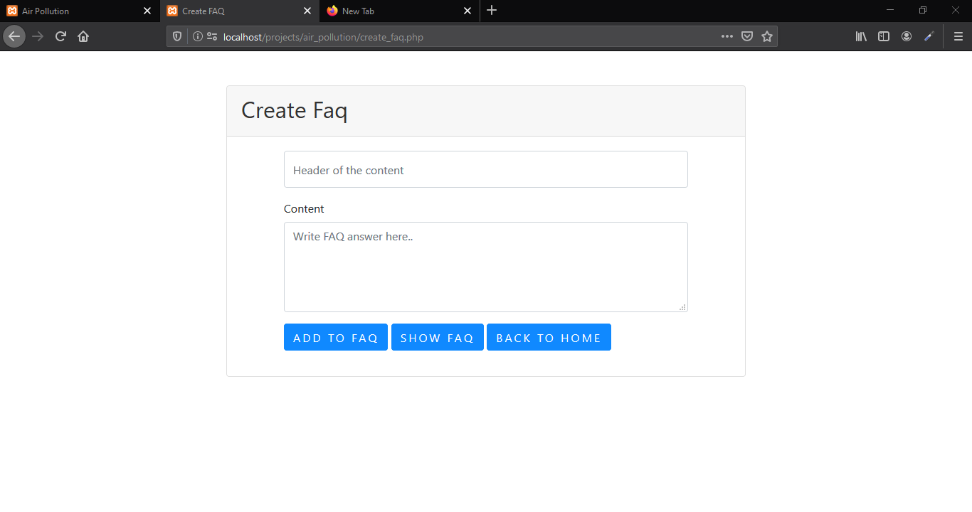

Figure 64: Add new faq for admin

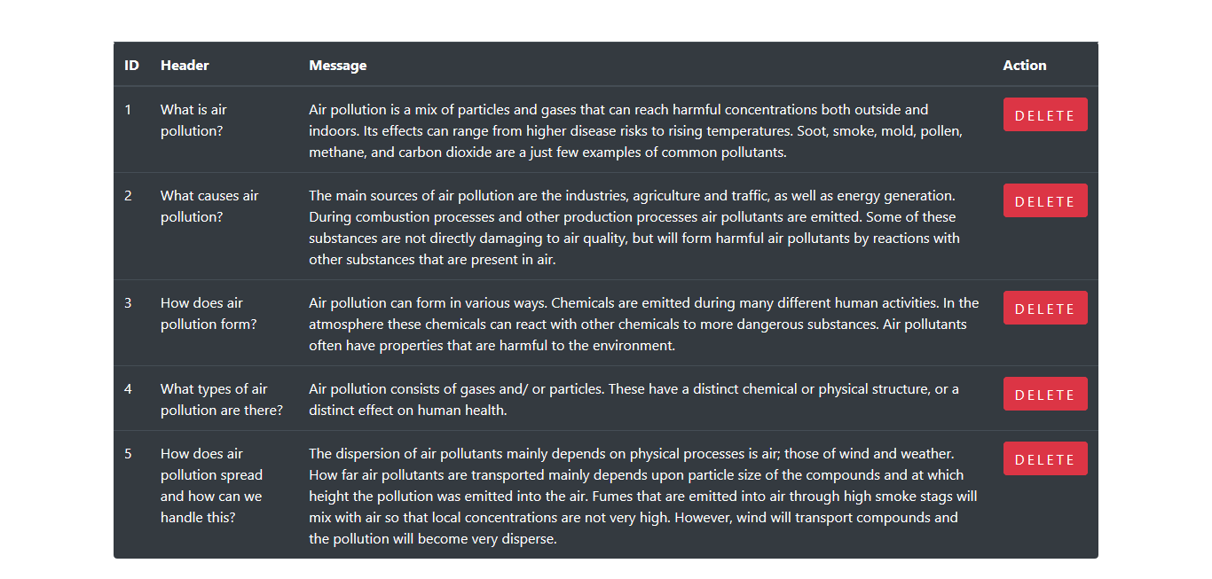

Figure 65: All FAQ

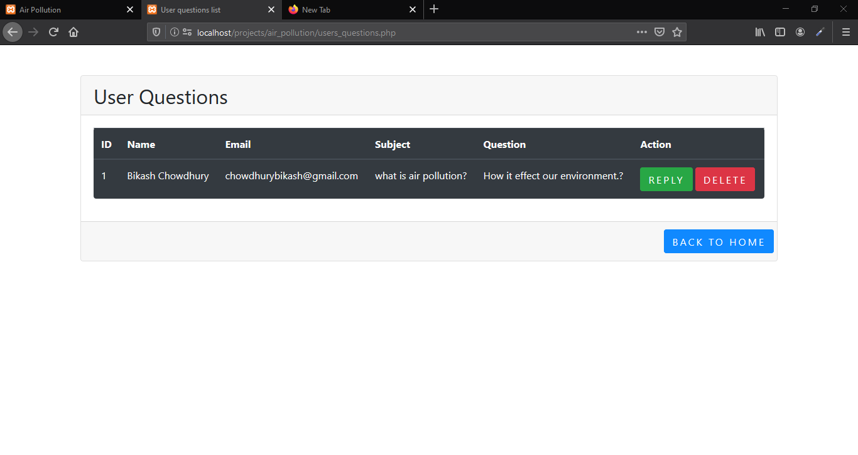

Figure 66: User questions shown for admin

# **Task-6**

## **1. What I have learned:**

In this assignment I was asked to build a dynamic website. I was also asked to make the website responsive and add features like sign up, login, registration, database, pop-up, hash security etc. I did not know how to solve many of these problems. My teacher helped me to solve many of these problems and I learned a lot about PHP,JavaScript, Bootstrap and JQuery through my teacher and by studying on my own and doing research. I also learned to solve problems in a systematic way within a fixed deadline.

## **2. The ways in which the system could be improved to become fully functional for mobile phones:**

There are tools provided my Google which can be used to test how much this website is mobile friendly. There is also a site called ‘mobile phone emulator’ through which I can test how the website works in different mobile phones.

The menu options can be made limited so as to fit well within the mobile screens that are smaller than the desktop screens.

The CTA or call to action buttons can be made more visible and easier to spot and there should be preferably one CTA per page which large enough to tap on because the mobile phone screen is smaller.

The text blocks can be made smaller because even small texts appear larger in small screens which might be inconvenient and difficult for readers.

## **3. The parts of the development process that were difficult**

While building this dynamic Website I faced some problems because it is an advanced task. The validation process which includes showing popups with the relevant errors when invalid information is entered by users, that process was quite difficult. It took a lot of time and effort. Also I have never worked on a system which blocks a user after a few attempts for giving wrong password. This feature was quite difficult to add. I also had some problems with time management.

## **4. The reason I chose responsive layout for this website and the advantages of responsive website:**

This website needs to be used in mobile as well as laptops and laptops that is the reason I chose the fluid responsive layout which can be suitable for mobiles and laptops and other devices. Adaptive website is not flexible and cannot resize and adjust in all devices like the responsive design.

The advantage of responsive design is that it is fluid, flexible and adjustable to any size screen and resolution but adaptive design cannot be like this flexible.

Responsive website garners more mobile traffic than those websites that are adaptive because responsive websites run better in mobile phones than adaptive websites

Responsive websites have lower building costs and lower maintenance time as they are more flexible than adaptive websites.

Responsive websites are very convenient for users to use because the there are no distorted images or any other such problems when responsive websites are accessed via mobile phones so users are more likely to continue using the website.

## **5. How I was able to overcome the problems:**

I was able to overcome the problems related to validation and blocking the user for inputting wrong passwords with the help of my teacher and through extensively studying the topic and watching tutorials on this. I also did group study to solve some problems.

However, I was not able to solve each and every problem so I will continue to pursue my research and study on these areas.